**Asignatura**

Programación orientada a objetos

**Estudiante**

Juan Camilo Herrera Sibaja

**Docente**

Walter Hugo Arboleda

**Grupo**

4

**Universidad Nacional de Colombia**

**Medellín**

**Ejercicio resuelto # 18**

**Void main Ejercicio_18**

package ejercicio_18;

public class Ejercicio_18 {

public static void main(String[] args) {

VentanaPrincipal_18 ventana18 = new VentanaPrincipal_18();

ventana18.show(true);

}

}

**Clase empleado**

package ejercicio_18;

public class Empleado{

int codigo;

String nombres;

double horasTrabajadas;

double valorHora;

double retencion;

public Empleado(int codigo, String nombres, double horasTrabajadas, double valorHora, double retencion) {

this.codigo = codigo;

this.nombres = nombres;

this.horasTrabajadas = horasTrabajadas;

this.valorHora = valorHora;

this.retencion = retencion;

}

public double calcularSalarioBruto() {

return horasTrabajadas * valorHora;

}

public double calcularSalarioNeto() {

double salarioBruto = calcularSalarioBruto();

return salarioBruto * (1 - retencion / 100);

}

**Interfaz Grafica**

package ejercicio_18;

public class VentanaPrincipal_18 extends javax.swing.JFrame {

public VentanaPrincipal_18() {

initComponents();

}

/**

* This method is called from within the constructor to initialize the form.

* WARNING: Do NOT modify this code. The content of this method is always

* regenerated by the Form Editor.

*/

@SuppressWarnings("unchecked")

// <editor-fold defaultstate="collapsed" desc="Generated Code">

private void initComponents() {

jLabel1 = new javax.swing.JLabel();

jLabel2 = new javax.swing.JLabel();

jLabel3 = new javax.swing.JLabel();

jLabel4 = new javax.swing.JLabel();

jLabel5 = new javax.swing.JLabel();

txtNombre = new javax.swing.JTextField();

txtCodigo = new javax.swing.JTextField();

txtHoras = new javax.swing.JTextField();

txtValor = new javax.swing.JTextField();

txtPorcentaje = new javax.swing.JTextField();

jLabel6 = new javax.swing.JLabel();

jLabel8 = new javax.swing.JLabel();

txtNeto = new javax.swing.JTextField();

btnSBruto = new javax.swing.JButton();

btnSNeto = new javax.swing.JButton();

btnBorrar = new javax.swing.JButton();

txtBruto = new javax.swing.JTextField();

jLabel7 = new javax.swing.JLabel();

jLabel9 = new javax.swing.JLabel();

jLabel10 = new javax.swing.JLabel();

txtImpCodigo = new javax.swing.JTextField();

txtImpNombre = new javax.swing.JTextField();

setDefaultCloseOperation(javax.swing.WindowConstants.EXIT_ON_CLOSE);

jLabel1.setText("Nombre");

jLabel2.setText("Código");

jLabel3.setText("Horas trabajadas al mes");

jLabel4.setText("Valor de la hora");

jLabel5.setText("Porcentaje de retención");

txtNombre.addActionListener(new java.awt.event.ActionListener() {

public void actionPerformed(java.awt.event.ActionEvent evt) {

txtNombreActionPerformed(evt);

}

});

txtHoras.addActionListener(new java.awt.event.ActionListener() {

public void actionPerformed(java.awt.event.ActionEvent evt) {

txtHorasActionPerformed(evt);

}

});

jLabel6.setForeground(new java.awt.Color(255, 0, 0));

jLabel6.setText("Empleado");

jLabel8.setText("Salario neto");

txtNeto.addActionListener(new java.awt.event.ActionListener() {

public void actionPerformed(java.awt.event.ActionEvent evt) {

txtNetoActionPerformed(evt);

}

});

btnSBruto.setText("Calcular Salario Bruto");

btnSBruto.addActionListener(new java.awt.event.ActionListener() {

public void actionPerformed(java.awt.event.ActionEvent evt) {

btnSBrutoActionPerformed(evt);

}

});

btnSNeto.setText("Calcular Salario Neto");

btnSNeto.addActionListener(new java.awt.event.ActionListener() {

public void actionPerformed(java.awt.event.ActionEvent evt) {

btnSNetoActionPerformed(evt);

}

});

btnBorrar.setText("Borrar");

btnBorrar.addActionListener(new java.awt.event.ActionListener() {

public void actionPerformed(java.awt.event.ActionEvent evt) {

btnBorrarActionPerformed(evt);

}

});

jLabel7.setText("Salario bruto");

jLabel9.setText("Nombre");

jLabel10.setText("Código");

txtImpCodigo.addActionListener(new java.awt.event.ActionListener() {

public void actionPerformed(java.awt.event.ActionEvent evt) {

txtImpCodigoActionPerformed(evt);

}

});

javax.swing.GroupLayout layout = new javax.swing.GroupLayout(getContentPane());

getContentPane().setLayout(layout);

layout.setHorizontalGroup(

layout.createParallelGroup(javax.swing.GroupLayout.Alignment.LEADING)

.addGroup(layout.createSequentialGroup()

.addGroup(layout.createParallelGroup(javax.swing.GroupLayout.Alignment.LEADING)

.addGroup(layout.createSequentialGroup()

.addGap(20, 20, 20)

.addGroup(layout.createParallelGroup(javax.swing.GroupLayout.Alignment.TRAILING)

.addComponent(jLabel2)

.addComponent(jLabel4)

.addComponent(jLabel3)

.addComponent(jLabel5)

.addComponent(jLabel1))

.addGap(18, 18, 18)

.addGroup(layout.createParallelGroup(javax.swing.GroupLayout.Alignment.TRAILING, false)

.addComponent(txtNombre, javax.swing.GroupLayout.Alignment.LEADING)

.addComponent(txtCodigo, javax.swing.GroupLayout.Alignment.LEADING)

.addComponent(txtHoras, javax.swing.GroupLayout.Alignment.LEADING)

.addComponent(txtValor, javax.swing.GroupLayout.Alignment.LEADING)

.addComponent(txtPorcentaje, javax.swing.GroupLayout.Alignment.LEADING, javax.swing.GroupLayout.PREFERRED_SIZE, 201, javax.swing.GroupLayout.PREFERRED_SIZE))

.addGroup(layout.createParallelGroup(javax.swing.GroupLayout.Alignment.LEADING)

.addGroup(layout.createSequentialGroup()

.addGap(41, 41, 41)

.addGroup(layout.createParallelGroup(javax.swing.GroupLayout.Alignment.TRAILING)

.addComponent(jLabel8)

.addComponent(jLabel7))

.addGap(18, 18, 18)

.addGroup(layout.createParallelGroup(javax.swing.GroupLayout.Alignment.LEADING)

.addComponent(txtBruto)

.addComponent(txtNeto)))

.addGroup(layout.createSequentialGroup()

.addGap(63, 63, 63)

.addGroup(layout.createParallelGroup(javax.swing.GroupLayout.Alignment.TRAILING)

.addComponent(jLabel10)

.addComponent(jLabel9))

.addGap(24, 24, 24)

.addGroup(layout.createParallelGroup(javax.swing.GroupLayout.Alignment.LEADING)

.addComponent(txtImpNombre, javax.swing.GroupLayout.Alignment.TRAILING, javax.swing.GroupLayout.PREFERRED_SIZE, 218, javax.swing.GroupLayout.PREFERRED_SIZE)

.addComponent(txtImpCodigo, javax.swing.GroupLayout.Alignment.TRAILING, javax.swing.GroupLayout.PREFERRED_SIZE, 218, javax.swing.GroupLayout.PREFERRED_SIZE)))))

.addGroup(layout.createSequentialGroup()

.addGap(374, 374, 374)

.addComponent(jLabel6))

.addGroup(layout.createSequentialGroup()

.addGap(213, 213, 213)

.addComponent(btnSBruto)

.addGap(18, 18, 18)

.addComponent(btnSNeto)

.addGap(18, 18, 18)

.addComponent(btnBorrar)))

.addGap(27, 27, 27))

);

layout.setVerticalGroup(

layout.createParallelGroup(javax.swing.GroupLayout.Alignment.LEADING)

.addGroup(layout.createSequentialGroup()

.addGap(18, 18, 18)

.addComponent(jLabel6)

.addGap(28, 28, 28)

.addGroup(layout.createParallelGroup(javax.swing.GroupLayout.Alignment.LEADING)

.addGroup(layout.createSequentialGroup()

.addGroup(layout.createParallelGroup(javax.swing.GroupLayout.Alignment.BASELINE)

.addComponent(txtNombre, javax.swing.GroupLayout.PREFERRED_SIZE, javax.swing.GroupLayout.DEFAULT_SIZE, javax.swing.GroupLayout.PREFERRED_SIZE)

.addComponent(jLabel1))

.addPreferredGap(javax.swing.LayoutStyle.ComponentPlacement.UNRELATED)

.addGroup(layout.createParallelGroup(javax.swing.GroupLayout.Alignment.BASELINE)

.addComponent(txtCodigo, javax.swing.GroupLayout.PREFERRED_SIZE, javax.swing.GroupLayout.DEFAULT_SIZE, javax.swing.GroupLayout.PREFERRED_SIZE)

.addComponent(jLabel2, javax.swing.GroupLayout.PREFERRED_SIZE, 16, javax.swing.GroupLayout.PREFERRED_SIZE)))

.addGroup(layout.createSequentialGroup()

.addGroup(layout.createParallelGroup(javax.swing.GroupLayout.Alignment.BASELINE)

.addComponent(txtImpCodigo, javax.swing.GroupLayout.PREFERRED_SIZE, javax.swing.GroupLayout.DEFAULT_SIZE, javax.swing.GroupLayout.PREFERRED_SIZE)

.addComponent(jLabel10, javax.swing.GroupLayout.PREFERRED_SIZE, 16, javax.swing.GroupLayout.PREFERRED_SIZE))

.addPreferredGap(javax.swing.LayoutStyle.ComponentPlacement.UNRELATED)

.addGroup(layout.createParallelGroup(javax.swing.GroupLayout.Alignment.BASELINE)

.addComponent(jLabel9)

.addComponent(txtImpNombre, javax.swing.GroupLayout.PREFERRED_SIZE, javax.swing.GroupLayout.DEFAULT_SIZE, javax.swing.GroupLayout.PREFERRED_SIZE))))

.addPreferredGap(javax.swing.LayoutStyle.ComponentPlacement.UNRELATED)

.addGroup(layout.createParallelGroup(javax.swing.GroupLayout.Alignment.LEADING)

.addGroup(layout.createSequentialGroup()

.addGroup(layout.createParallelGroup(javax.swing.GroupLayout.Alignment.BASELINE)

.addComponent(txtHoras, javax.swing.GroupLayout.PREFERRED_SIZE, javax.swing.GroupLayout.DEFAULT_SIZE, javax.swing.GroupLayout.PREFERRED_SIZE)

.addComponent(jLabel3))

.addPreferredGap(javax.swing.LayoutStyle.ComponentPlacement.UNRELATED)

.addGroup(layout.createParallelGroup(javax.swing.GroupLayout.Alignment.BASELINE)

.addComponent(jLabel4)

.addComponent(txtValor, javax.swing.GroupLayout.PREFERRED_SIZE, javax.swing.GroupLayout.DEFAULT_SIZE, javax.swing.GroupLayout.PREFERRED_SIZE)))

.addGroup(layout.createSequentialGroup()

.addGroup(layout.createParallelGroup(javax.swing.GroupLayout.Alignment.BASELINE)

.addComponent(jLabel7)

.addComponent(txtBruto, javax.swing.GroupLayout.PREFERRED_SIZE, 22, javax.swing.GroupLayout.PREFERRED_SIZE))

.addGap(15, 15, 15)

.addGroup(layout.createParallelGroup(javax.swing.GroupLayout.Alignment.BASELINE)

.addComponent(txtNeto, javax.swing.GroupLayout.PREFERRED_SIZE, javax.swing.GroupLayout.DEFAULT_SIZE, javax.swing.GroupLayout.PREFERRED_SIZE)

.addComponent(jLabel8))))

.addPreferredGap(javax.swing.LayoutStyle.ComponentPlacement.UNRELATED)

.addGroup(layout.createParallelGroup(javax.swing.GroupLayout.Alignment.BASELINE)

.addComponent(txtPorcentaje, javax.swing.GroupLayout.PREFERRED_SIZE, javax.swing.GroupLayout.DEFAULT_SIZE, javax.swing.GroupLayout.PREFERRED_SIZE)

.addComponent(jLabel5))

.addGap(28, 28, 28)

.addGroup(layout.createParallelGroup(javax.swing.GroupLayout.Alignment.BASELINE)

.addComponent(btnSBruto)

.addComponent(btnSNeto)

.addComponent(btnBorrar))

.addContainerGap(19, Short.MAX_VALUE))

);

pack();

}// </editor-fold>

private void txtNombreActionPerformed(java.awt.event.ActionEvent evt) {

// TODO add your handling code here:

}

private void txtNetoActionPerformed(java.awt.event.ActionEvent evt) {

// TODO add your handling code here:

}

private void btnSNetoActionPerformed(java.awt.event.ActionEvent evt) {

double SalarioNeto;

double horastrabajadas = Double.parseDouble(txtHoras.getText());

double valorhora = Double.parseDouble(txtValor.getText());

double retencion = Double.parseDouble(txtPorcentaje.getText());

int codigo = Integer.parseInt(txtCodigo.getText());

String nombre = txtNombre.getText();

txtImpNombre.setText(nombre);

Empleado trabajador1 = new Empleado(codigo, nombre, horastrabajadas, valorhora, retencion);

SalarioNeto = trabajador1.calcularSalarioNeto();

txtNeto.setText(String.valueOf(SalarioNeto));

txtImpCodigo.setText(String.valueOf(codigo));

}

private void btnSBrutoActionPerformed(java.awt.event.ActionEvent evt) {

double SalarioBruto;

double horastrabajadas = Double.parseDouble(txtHoras.getText());

double valorhora = Double.parseDouble(txtValor.getText());

int codigo = Integer.parseInt(txtCodigo.getText());

String nombre = txtNombre.getText();

txtImpNombre.setText(nombre);

Empleado trabajador = new Empleado(codigo, nombre, horastrabajadas, valorhora, 0);

SalarioBruto = trabajador.calcularSalarioBruto();

txtBruto.setText(String.valueOf(SalarioBruto));

txtImpCodigo.setText(String.valueOf(codigo));

}

private void txtHorasActionPerformed(java.awt.event.ActionEvent evt) {

// TODO add your handling code here:

}

private void btnBorrarActionPerformed(java.awt.event.ActionEvent evt) {

txtNombre.setText("");

txtCodigo.setText("");

txtHoras.setText("");

txtValor.setText("");

txtPorcentaje.setText("");

txtBruto.setText("");

txtNeto.setText("");

txtImpCodigo.setText("");

txtImpNombre.setText("");

}

private void txtImpCodigoActionPerformed(java.awt.event.ActionEvent evt) {

// TODO add your handling code here:

}

/**

* @param args the command line arguments

*/

public static void main(String args[]) {

/* Set the Nimbus look and feel */

//<editor-fold defaultstate="collapsed" desc=" Look and feel setting code (optional) ">

/* If Nimbus (introduced in Java SE 6) is not available, stay with the default look and feel.

* For details see http://download.oracle.com/javase/tutorial/uiswing/lookandfeel/plaf.html

*/

try {

for (javax.swing.UIManager.LookAndFeelInfo info : javax.swing.UIManager.getInstalledLookAndFeels()) {

if ("Nimbus".equals(info.getName())) {

javax.swing.UIManager.setLookAndFeel(info.getClassName());

break;

}

}

} catch (ClassNotFoundException ex) {

java.util.logging.Logger.getLogger(VentanaPrincipal_18.class.getName()).log(java.util.logging.Level.SEVERE, null, ex);

} catch (InstantiationException ex) {

java.util.logging.Logger.getLogger(VentanaPrincipal_18.class.getName()).log(java.util.logging.Level.SEVERE, null, ex);

} catch (IllegalAccessException ex) {

java.util.logging.Logger.getLogger(VentanaPrincipal_18.class.getName()).log(java.util.logging.Level.SEVERE, null, ex);

} catch (javax.swing.UnsupportedLookAndFeelException ex) {

java.util.logging.Logger.getLogger(VentanaPrincipal_18.class.getName()).log(java.util.logging.Level.SEVERE, null, ex);

}

//</editor-fold>

/* Create and display the form */

java.awt.EventQueue.invokeLater(new Runnable() {

public void run() {

new VentanaPrincipal_18().setVisible(true);

}

});

}

// Variables declaration - do not modify

private javax.swing.JButton btnBorrar;

private javax.swing.JButton btnSBruto;

private javax.swing.JButton btnSNeto;

private javax.swing.JLabel jLabel1;

private javax.swing.JLabel jLabel10;

private javax.swing.JLabel jLabel2;

private javax.swing.JLabel jLabel3;

private javax.swing.JLabel jLabel4;

private javax.swing.JLabel jLabel5;

private javax.swing.JLabel jLabel6;

private javax.swing.JLabel jLabel7;

private javax.swing.JLabel jLabel8;

private javax.swing.JLabel jLabel9;

private javax.swing.JTextField txtBruto;

private javax.swing.JTextField txtCodigo;

private javax.swing.JTextField txtHoras;

private javax.swing.JTextField txtImpCodigo;

private javax.swing.JTextField txtImpNombre;

private javax.swing.JTextField txtNeto;

private javax.swing.JTextField txtNombre;

private javax.swing.JTextField txtPorcentaje;

private javax.swing.JTextField txtValor;

// End of variables declaration

}

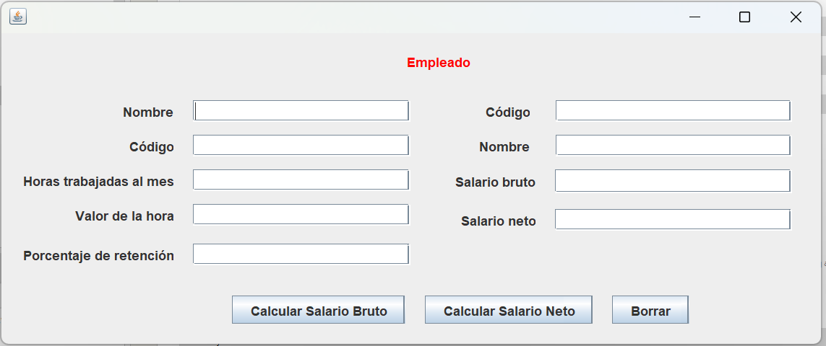

**Diagrama UML**

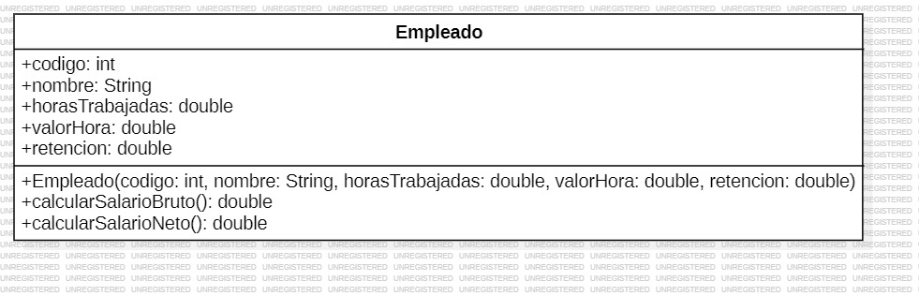

**Links:** <https://github.com/juancoficial7/actividad3/tree/main/Ejercicio_18>

**Ejercicio resuelto # 19**

**Interface de consola TrianguloEquilatero**

package ejercicio_19;

public interface TrianguloEquilatero {

double calcularPerimetro(double lado);

double calcularAltura(double lado);

double calcularArea(double lado);

**Void main Ejercicio_19**

package ejercicio_19;

public class Ejercicio_19 {

public static void main(String[] args) {

VentanaPrincipal_19 calcular = new VentanaPrincipal_19();

calcular.show(true);

}

}

**clase CalculadoraTrianguloEquilatero**

package ejercicio_19;

public class CalculadoraTrianguloEquilatero implements TrianguloEquilatero {

@Override

public double calcularPerimetro(double lado) {

return lado * 3; // El perímetro de un triángulo equilátero es igual al lado multiplicado por 3

}

@Override

public double calcularAltura(double lado) {

return (Math.sqrt(3) / 2) * lado; // La altura de un triángulo equilátero es igual a la raíz cuadrada de 3 dividida por 2, multiplicada por el lado

}

@Override

public double calcularArea(double lado) {

return (Math.sqrt(3) / 4) * lado * lado; // El área de un triángulo equilátero es igual a la raíz cuadrada de 3 dividida por 4, multiplicada por el lado al cuadrado

}

}

**Interfaz Grafica**

package ejercicio_19;

public class VentanaPrincipal_19 extends javax.swing.JFrame {

public VentanaPrincipal_19() {

initComponents();

}

@SuppressWarnings("unchecked")

// <editor-fold defaultstate="collapsed" desc="Generated Code">

private void initComponents() {

jLabel1 = new javax.swing.JLabel();

jLabel2 = new javax.swing.JLabel();

jLabel3 = new javax.swing.JLabel();

jLabel4 = new javax.swing.JLabel();

jLabel5 = new javax.swing.JLabel();

txtLado = new javax.swing.JTextField();

txtPerimetro = new javax.swing.JTextField();

txtAltura = new javax.swing.JTextField();

txtArea = new javax.swing.JTextField();

btnPerimetro = new javax.swing.JButton();

btnAltura = new javax.swing.JButton();

btnArea = new javax.swing.JButton();

btnBorrar = new javax.swing.JButton();

setDefaultCloseOperation(javax.swing.WindowConstants.EXIT_ON_CLOSE);

jLabel1.setForeground(new java.awt.Color(204, 0, 0));

jLabel1.setText("Triangulo Equilatero");

jLabel2.setText("Lado");

jLabel3.setText("Perimetro");

jLabel4.setText("Altura");

jLabel5.setText("Area");

btnPerimetro.setText("Calcular Perimetro");

btnPerimetro.addActionListener(new java.awt.event.ActionListener() {

public void actionPerformed(java.awt.event.ActionEvent evt) {

btnPerimetroActionPerformed(evt);

}

});

btnAltura.setText("Calcular Altura");

btnAltura.addActionListener(new java.awt.event.ActionListener() {

public void actionPerformed(java.awt.event.ActionEvent evt) {

btnAlturaActionPerformed(evt);

}

});

btnArea.setText("Calcular Area");

btnArea.addActionListener(new java.awt.event.ActionListener() {

public void actionPerformed(java.awt.event.ActionEvent evt) {

btnAreaActionPerformed(evt);

}

});

btnBorrar.setText("Borrar");

btnBorrar.addActionListener(new java.awt.event.ActionListener() {

public void actionPerformed(java.awt.event.ActionEvent evt) {

btnBorrarActionPerformed(evt);

}

});

javax.swing.GroupLayout layout = new javax.swing.GroupLayout(getContentPane());

getContentPane().setLayout(layout);

layout.setHorizontalGroup(

layout.createParallelGroup(javax.swing.GroupLayout.Alignment.LEADING)

.addGroup(layout.createSequentialGroup()

.addGroup(layout.createParallelGroup(javax.swing.GroupLayout.Alignment.LEADING)

.addGroup(layout.createSequentialGroup()

.addGap(197, 197, 197)

.addComponent(jLabel1))

.addGroup(layout.createSequentialGroup()

.addGap(87, 87, 87)

.addGroup(layout.createParallelGroup(javax.swing.GroupLayout.Alignment.LEADING)

.addComponent(jLabel2)

.addComponent(jLabel3)

.addComponent(jLabel4)

.addComponent(jLabel5))

.addGap(43, 43, 43)

.addGroup(layout.createParallelGroup(javax.swing.GroupLayout.Alignment.LEADING, false)

.addComponent(txtLado)

.addComponent(txtPerimetro)

.addComponent(txtAltura)

.addComponent(txtArea, javax.swing.GroupLayout.DEFAULT_SIZE, 185, Short.MAX_VALUE)))

.addGroup(layout.createSequentialGroup()

.addGap(24, 24, 24)

.addComponent(btnPerimetro)

.addPreferredGap(javax.swing.LayoutStyle.ComponentPlacement.UNRELATED)

.addComponent(btnAltura)

.addPreferredGap(javax.swing.LayoutStyle.ComponentPlacement.UNRELATED)

.addComponent(btnArea)

.addPreferredGap(javax.swing.LayoutStyle.ComponentPlacement.UNRELATED)

.addComponent(btnBorrar)))

.addContainerGap(49, Short.MAX_VALUE))

);

layout.setVerticalGroup(

layout.createParallelGroup(javax.swing.GroupLayout.Alignment.LEADING)

.addGroup(layout.createSequentialGroup()

.addContainerGap()

.addComponent(jLabel1)

.addGap(27, 27, 27)

.addGroup(layout.createParallelGroup(javax.swing.GroupLayout.Alignment.BASELINE)

.addComponent(jLabel2)

.addComponent(txtLado, javax.swing.GroupLayout.PREFERRED_SIZE, javax.swing.GroupLayout.DEFAULT_SIZE, javax.swing.GroupLayout.PREFERRED_SIZE))

.addGap(18, 18, 18)

.addGroup(layout.createParallelGroup(javax.swing.GroupLayout.Alignment.BASELINE)

.addComponent(jLabel3)

.addComponent(txtPerimetro, javax.swing.GroupLayout.PREFERRED_SIZE, javax.swing.GroupLayout.DEFAULT_SIZE, javax.swing.GroupLayout.PREFERRED_SIZE))

.addGap(18, 18, 18)

.addGroup(layout.createParallelGroup(javax.swing.GroupLayout.Alignment.BASELINE)

.addComponent(jLabel4)

.addComponent(txtAltura, javax.swing.GroupLayout.PREFERRED_SIZE, javax.swing.GroupLayout.DEFAULT_SIZE, javax.swing.GroupLayout.PREFERRED_SIZE))

.addGap(18, 18, 18)

.addGroup(layout.createParallelGroup(javax.swing.GroupLayout.Alignment.BASELINE)

.addComponent(jLabel5)

.addComponent(txtArea, javax.swing.GroupLayout.PREFERRED_SIZE, javax.swing.GroupLayout.DEFAULT_SIZE, javax.swing.GroupLayout.PREFERRED_SIZE))

.addGap(26, 26, 26)

.addGroup(layout.createParallelGroup(javax.swing.GroupLayout.Alignment.BASELINE)

.addComponent(btnPerimetro)

.addComponent(btnAltura)

.addComponent(btnArea)

.addComponent(btnBorrar))

.addContainerGap(69, Short.MAX_VALUE))

);

pack();

}// </editor-fold>

private void btnPerimetroActionPerformed(java.awt.event.ActionEvent evt) {

double perimetroTrian;

double lado = Double.parseDouble(txtLado.getText());

CalculadoraTrianguloEquilatero periTri = new CalculadoraTrianguloEquilatero();

perimetroTrian = periTri.calcularPerimetro(lado);

txtPerimetro.setText(String.valueOf(perimetroTrian));

}

private void btnBorrarActionPerformed(java.awt.event.ActionEvent evt) {

txtLado.setText("");

txtPerimetro.setText("");

txtAltura.setText("");

txtArea.setText("");

}

private void btnAlturaActionPerformed(java.awt.event.ActionEvent evt) {

double alturaTriangulo;

double lado = Double.parseDouble(txtLado.getText());

CalculadoraTrianguloEquilatero alturaTri = new CalculadoraTrianguloEquilatero();

alturaTriangulo = alturaTri.calcularAltura(lado);

txtAltura.setText(String.valueOf(alturaTriangulo));

}

private void btnAreaActionPerformed(java.awt.event.ActionEvent evt) {

double areaTriangulo;

double lado = Double.parseDouble(txtLado.getText());

CalculadoraTrianguloEquilatero areaTri = new CalculadoraTrianguloEquilatero();

areaTriangulo = areaTri.calcularArea(lado);

txtArea.setText(String.valueOf(areaTriangulo));

}

public static void main(String args[]) {

/* Set the Nimbus look and feel */

//<editor-fold defaultstate="collapsed" desc=" Look and feel setting code (optional) ">

/* If Nimbus (introduced in Java SE 6) is not available, stay with the default look and feel.

* For details see http://download.oracle.com/javase/tutorial/uiswing/lookandfeel/plaf.html

*/

try {

for (javax.swing.UIManager.LookAndFeelInfo info : javax.swing.UIManager.getInstalledLookAndFeels()) {

if ("Nimbus".equals(info.getName())) {

javax.swing.UIManager.setLookAndFeel(info.getClassName());

break;

}

}

} catch (ClassNotFoundException ex) {

java.util.logging.Logger.getLogger(VentanaPrincipal_19.class.getName()).log(java.util.logging.Level.SEVERE, null, ex);

} catch (InstantiationException ex) {

java.util.logging.Logger.getLogger(VentanaPrincipal_19.class.getName()).log(java.util.logging.Level.SEVERE, null, ex);

} catch (IllegalAccessException ex) {

java.util.logging.Logger.getLogger(VentanaPrincipal_19.class.getName()).log(java.util.logging.Level.SEVERE, null, ex);

} catch (javax.swing.UnsupportedLookAndFeelException ex) {

java.util.logging.Logger.getLogger(VentanaPrincipal_19.class.getName()).log(java.util.logging.Level.SEVERE, null, ex);

}

//</editor-fold>

/* Create and display the form */

java.awt.EventQueue.invokeLater(new Runnable() {

public void run() {

new VentanaPrincipal_19().setVisible(true);

}

});

}

// Variables declaration - do not modify

private javax.swing.JButton btnAltura;

private javax.swing.JButton btnArea;

private javax.swing.JButton btnBorrar;

private javax.swing.JButton btnPerimetro;

private javax.swing.JLabel jLabel1;

private javax.swing.JLabel jLabel2;

private javax.swing.JLabel jLabel3;

private javax.swing.JLabel jLabel4;

private javax.swing.JLabel jLabel5;

private javax.swing.JTextField txtAltura;

private javax.swing.JTextField txtArea;

private javax.swing.JTextField txtLado;

private javax.swing.JTextField txtPerimetro;

// End of variables declaration

}

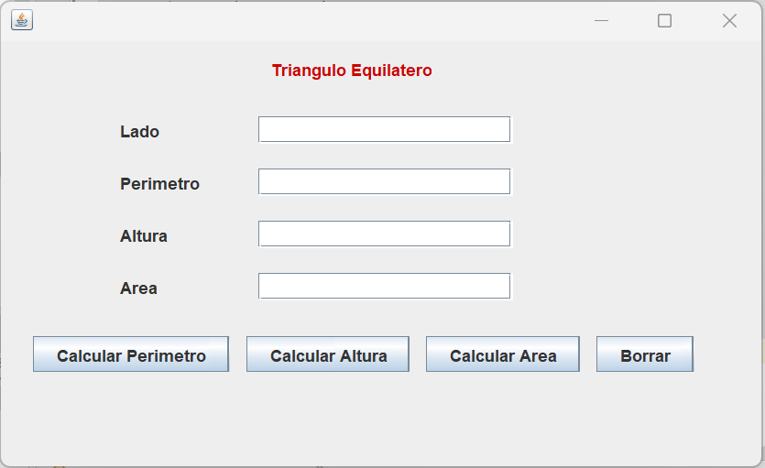

**Diagrama UML**

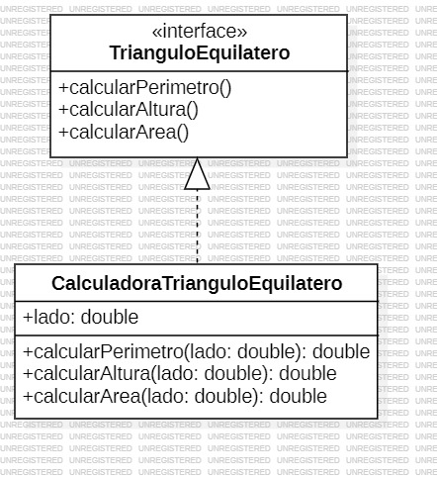

**Links:** <https://github.com/juancoficial7/actividad3/tree/main/Ejercicio_18>

**Ejercicio resuelto # 7**

**Interface de consola InterfazEjercicio7**

package ejerciciores_7;

public interface InterfazEjercicio7 {

double Comparar(double A,double B);

}

**Clase Comparador**

package ejerciciores_7;

public class Comparador implements InterfazEjercicio7{

double A;

double B;

public Comparador(double A, double B) {

this.A = A;

this.B = B;

}

public String Comparar() {

if (A > B) {

return "A es mayor que B";

} else if (A == B) {

return "A es igual a B";

} else {

return "A es menor que B";

}

}

@Override

public double Comparar(double A, double B) {

throw new UnsupportedOperationException("Not supported yet.");

}

}

**Void main EjercicioRes_7**

package ejerciciores_7;

public class EjercicioRes_7 {

public static void main(String[] args) {

VentanaPrincipal_7 comparador = new VentanaPrincipal_7();

comparador.show(true);

}

}

**Interfaz Grafica**

package ejerciciores_7;

public class VentanaPrincipal_7 extends javax.swing.JFrame {

public VentanaPrincipal_7() {

initComponents();

}

@SuppressWarnings("unchecked")

// <editor-fold defaultstate="collapsed" desc="Generated Code">

private void initComponents() {

jLabel1 = new javax.swing.JLabel();

jLabel2 = new javax.swing.JLabel();

jLabel3 = new javax.swing.JLabel();

jLabel4 = new javax.swing.JLabel();

txtValorA = new javax.swing.JTextField();

txtValorB = new javax.swing.JTextField();

txtResultado = new javax.swing.JTextField();

btnCalcular = new javax.swing.JButton();

btnBorrar = new javax.swing.JButton();

setDefaultCloseOperation(javax.swing.WindowConstants.EXIT_ON_CLOSE);

jLabel1.setForeground(new java.awt.Color(255, 0, 0));

jLabel1.setText("Comparador");

jLabel2.setText("Ingrese el Valor de A");

jLabel3.setText("Ingrese el Valor de B");

jLabel4.setText("Resultado");

btnCalcular.setText("Calcular");

btnCalcular.addActionListener(new java.awt.event.ActionListener() {

public void actionPerformed(java.awt.event.ActionEvent evt) {

btnCalcularActionPerformed(evt);

}

});

btnBorrar.setText("Borrar");

btnBorrar.addActionListener(new java.awt.event.ActionListener() {

public void actionPerformed(java.awt.event.ActionEvent evt) {

btnBorrarActionPerformed(evt);

}

});

javax.swing.GroupLayout layout = new javax.swing.GroupLayout(getContentPane());

getContentPane().setLayout(layout);

layout.setHorizontalGroup(

layout.createParallelGroup(javax.swing.GroupLayout.Alignment.LEADING)

.addGroup(layout.createSequentialGroup()

.addGroup(layout.createParallelGroup(javax.swing.GroupLayout.Alignment.LEADING)

.addGroup(layout.createSequentialGroup()

.addGap(216, 216, 216)

.addComponent(jLabel1))

.addGroup(layout.createSequentialGroup()

.addGap(79, 79, 79)

.addGroup(layout.createParallelGroup(javax.swing.GroupLayout.Alignment.LEADING)

.addGroup(layout.createSequentialGroup()

.addGroup(layout.createParallelGroup(javax.swing.GroupLayout.Alignment.TRAILING)

.addComponent(jLabel3)

.addComponent(jLabel2)

.addComponent(jLabel4))

.addGap(44, 44, 44)

.addGroup(layout.createParallelGroup(javax.swing.GroupLayout.Alignment.LEADING)

.addGroup(layout.createParallelGroup(javax.swing.GroupLayout.Alignment.LEADING, false)

.addComponent(txtValorA, javax.swing.GroupLayout.DEFAULT_SIZE, 146, Short.MAX_VALUE)

.addComponent(txtValorB))

.addComponent(txtResultado, javax.swing.GroupLayout.PREFERRED_SIZE, 196, javax.swing.GroupLayout.PREFERRED_SIZE)))

.addGroup(layout.createSequentialGroup()

.addGap(56, 56, 56)

.addComponent(btnCalcular)

.addGap(35, 35, 35)

.addComponent(btnBorrar)))))

.addContainerGap(50, Short.MAX_VALUE))

);

layout.setVerticalGroup(

layout.createParallelGroup(javax.swing.GroupLayout.Alignment.LEADING)

.addGroup(layout.createSequentialGroup()

.addContainerGap()

.addComponent(jLabel1)

.addGap(18, 18, 18)

.addGroup(layout.createParallelGroup(javax.swing.GroupLayout.Alignment.BASELINE)

.addComponent(jLabel2)

.addComponent(txtValorA, javax.swing.GroupLayout.PREFERRED_SIZE, javax.swing.GroupLayout.DEFAULT_SIZE, javax.swing.GroupLayout.PREFERRED_SIZE))

.addGap(18, 18, 18)

.addGroup(layout.createParallelGroup(javax.swing.GroupLayout.Alignment.BASELINE)

.addComponent(jLabel3)

.addComponent(txtValorB, javax.swing.GroupLayout.PREFERRED_SIZE, javax.swing.GroupLayout.DEFAULT_SIZE, javax.swing.GroupLayout.PREFERRED_SIZE))

.addGap(18, 18, 18)

.addGroup(layout.createParallelGroup(javax.swing.GroupLayout.Alignment.BASELINE)

.addComponent(jLabel4)

.addComponent(txtResultado, javax.swing.GroupLayout.PREFERRED_SIZE, javax.swing.GroupLayout.DEFAULT_SIZE, javax.swing.GroupLayout.PREFERRED_SIZE))

.addGap(18, 18, 18)

.addGroup(layout.createParallelGroup(javax.swing.GroupLayout.Alignment.BASELINE)

.addComponent(btnCalcular)

.addComponent(btnBorrar))

.addContainerGap(57, Short.MAX_VALUE))

);

pack();

}// </editor-fold>

private void btnCalcularActionPerformed(java.awt.event.ActionEvent evt) {

String Almacenado;

double ValorA = Double.parseDouble(txtValorA.getText());

double ValorB = Double.parseDouble(txtValorB.getText());

Comparador comparo = new Comparador(ValorA,ValorB);

Almacenado = comparo.Comparar();

txtResultado.setText(String.valueOf(Almacenado));

}

private void btnBorrarActionPerformed(java.awt.event.ActionEvent evt) {

txtValorA.setText("");

txtValorB.setText("");

txtResultado.setText("");

}

public static void main(String args[]) {

/* Set the Nimbus look and feel */

//<editor-fold defaultstate="collapsed" desc=" Look and feel setting code (optional) ">

/* If Nimbus (introduced in Java SE 6) is not available, stay with the default look and feel.

* For details see http://download.oracle.com/javase/tutorial/uiswing/lookandfeel/plaf.html

*/

try {

for (javax.swing.UIManager.LookAndFeelInfo info : javax.swing.UIManager.getInstalledLookAndFeels()) {

if ("Nimbus".equals(info.getName())) {

javax.swing.UIManager.setLookAndFeel(info.getClassName());

break;

}

}

} catch (ClassNotFoundException ex) {

java.util.logging.Logger.getLogger(VentanaPrincipal_7.class.getName()).log(java.util.logging.Level.SEVERE, null, ex);

} catch (InstantiationException ex) {

java.util.logging.Logger.getLogger(VentanaPrincipal_7.class.getName()).log(java.util.logging.Level.SEVERE, null, ex);

} catch (IllegalAccessException ex) {

java.util.logging.Logger.getLogger(VentanaPrincipal_7.class.getName()).log(java.util.logging.Level.SEVERE, null, ex);

} catch (javax.swing.UnsupportedLookAndFeelException ex) {

java.util.logging.Logger.getLogger(VentanaPrincipal_7.class.getName()).log(java.util.logging.Level.SEVERE, null, ex);

}

//</editor-fold>

/* Create and display the form */

java.awt.EventQueue.invokeLater(new Runnable() {

public void run() {

new VentanaPrincipal_7().setVisible(true);

}

});

}

// Variables declaration - do not modify

private javax.swing.JButton btnBorrar;

private javax.swing.JButton btnCalcular;

private javax.swing.JLabel jLabel1;

private javax.swing.JLabel jLabel2;

private javax.swing.JLabel jLabel3;

private javax.swing.JLabel jLabel4;

private javax.swing.JTextField txtResultado;

private javax.swing.JTextField txtValorA;

private javax.swing.JTextField txtValorB;

// End of variables declaration

}

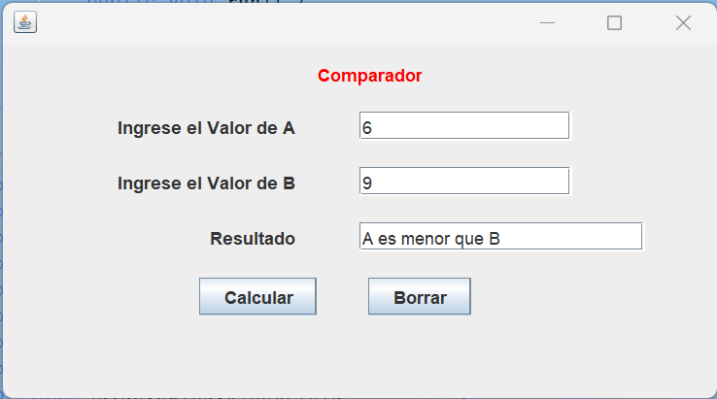

**Diagrama UML**

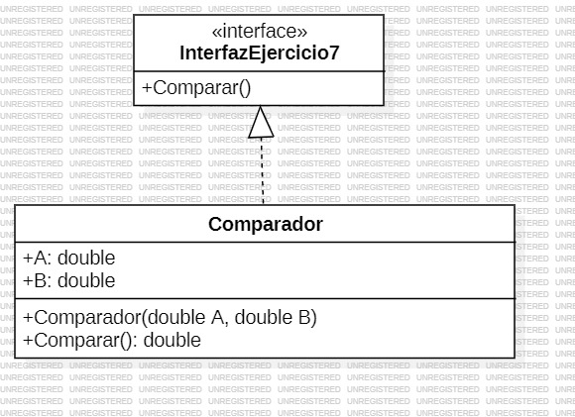

**Links:** <https://github.com/juancoficial7/actividad3/tree/main/EjercicioRes_7>

**Ejercicio resuelto # 10**

**Interface de consola InterfazEjercicio10**

package ejerciciores_10;

public interface InterfazEjercicio10 {

int PagoMatricula(int PAT, int EST);

}

**clase PagoEstudiante**

package ejerciciores_10;

public class PagoEstudiante implements InterfazEjercicio10 {

double NI; //Número de inscripción.

String NOM; //Nombre

String APE; //Apellidos

int PAT; //Patrimonio

int EST; //Estrato social

public PagoEstudiante( int PAT, int EST) {

this.PAT = PAT;

this.EST = EST;

}

@Override

public int PagoMatricula(int PAT, int EST) {

int PAGMAT = 50000;

if (PAT > 2000000 && EST > 3) {

PAGMAT = (int) (PAGMAT + (0.03 * PAT));

}

return PAGMAT;

}

}

**Void main EjercicioRes_10**

package ejerciciores_10;

public class EjercicioRes_10 {

public static void main(String[] args) {

InterfazEjercicioRes_10 matricula = new InterfazEjercicioRes_10();

matricula.show(true);

}

**Interfaz Grafica**

package ejerciciores_10;

public class InterfazEjercicioRes_10 extends javax.swing.JFrame {

public InterfazEjercicioRes_10() {

initComponents();

}

@SuppressWarnings("unchecked")

// <editor-fold defaultstate="collapsed" desc="Generated Code">

private void initComponents() {

jLabel1 = new javax.swing.JLabel();

jLabel2 = new javax.swing.JLabel();

jLabel3 = new javax.swing.JLabel();

jLabel4 = new javax.swing.JLabel();

jLabel5 = new javax.swing.JLabel();

txtInscripcion = new javax.swing.JTextField();

txtNombre = new javax.swing.JTextField();

txtPatrimonio = new javax.swing.JTextField();

txtEstrato = new javax.swing.JTextField();

jLabel6 = new javax.swing.JLabel();

jLabel7 = new javax.swing.JLabel();

jLabel8 = new javax.swing.JLabel();

txtSaInscripcion = new javax.swing.JTextField();

txtSalNombre = new javax.swing.JTextField();

txtSalMatricula = new javax.swing.JTextField();

btnCalcularPago = new javax.swing.JButton();

btnBorrar = new javax.swing.JButton();

setDefaultCloseOperation(javax.swing.WindowConstants.EXIT_ON_CLOSE);

jLabel1.setForeground(new java.awt.Color(255, 0, 0));

jLabel1.setText("Costo Matricula Universidad");

jLabel2.setText("Número de inscripción");

jLabel3.setText("Nombre");

jLabel4.setText("Patrimonio");

jLabel5.setText("Estrato social");

txtInscripcion.addActionListener(new java.awt.event.ActionListener() {

public void actionPerformed(java.awt.event.ActionEvent evt) {

txtInscripcionActionPerformed(evt);

}

});

jLabel6.setText("Número de inscripción");

jLabel7.setText("Nombre");

jLabel8.setText("Pago Por Matricula");

btnCalcularPago.setText("Calcular Pago Matricula");

btnCalcularPago.addActionListener(new java.awt.event.ActionListener() {

public void actionPerformed(java.awt.event.ActionEvent evt) {

btnCalcularPagoActionPerformed(evt);

}

});

btnBorrar.setText("Borrar");

btnBorrar.addActionListener(new java.awt.event.ActionListener() {

public void actionPerformed(java.awt.event.ActionEvent evt) {

btnBorrarActionPerformed(evt);

}

});

javax.swing.GroupLayout layout = new javax.swing.GroupLayout(getContentPane());

getContentPane().setLayout(layout);

layout.setHorizontalGroup(

layout.createParallelGroup(javax.swing.GroupLayout.Alignment.LEADING)

.addGroup(layout.createSequentialGroup()

.addGroup(layout.createParallelGroup(javax.swing.GroupLayout.Alignment.LEADING)

.addGroup(layout.createSequentialGroup()

.addGap(250, 250, 250)

.addComponent(jLabel1))

.addGroup(layout.createSequentialGroup()

.addGap(26, 26, 26)

.addGroup(layout.createParallelGroup(javax.swing.GroupLayout.Alignment.LEADING)

.addComponent(jLabel2)

.addComponent(jLabel3, javax.swing.GroupLayout.Alignment.TRAILING)

.addComponent(jLabel4, javax.swing.GroupLayout.Alignment.TRAILING)

.addComponent(jLabel5, javax.swing.GroupLayout.Alignment.TRAILING))

.addGap(32, 32, 32)

.addGroup(layout.createParallelGroup(javax.swing.GroupLayout.Alignment.LEADING, false)

.addComponent(txtInscripcion)

.addComponent(txtNombre)

.addComponent(txtPatrimonio)

.addComponent(txtEstrato, javax.swing.GroupLayout.DEFAULT_SIZE, 167, Short.MAX_VALUE))

.addGap(36, 36, 36)

.addGroup(layout.createParallelGroup(javax.swing.GroupLayout.Alignment.LEADING)

.addComponent(jLabel6)

.addComponent(jLabel7, javax.swing.GroupLayout.Alignment.TRAILING)

.addComponent(jLabel8, javax.swing.GroupLayout.Alignment.TRAILING))

.addGap(36, 36, 36)

.addGroup(layout.createParallelGroup(javax.swing.GroupLayout.Alignment.LEADING)

.addComponent(txtSalMatricula)

.addGroup(layout.createSequentialGroup()

.addComponent(txtSaInscripcion, javax.swing.GroupLayout.PREFERRED_SIZE, 180, javax.swing.GroupLayout.PREFERRED_SIZE)

.addGap(0, 0, Short.MAX_VALUE))

.addComponent(txtSalNombre))))

.addGap(25, 25, 25))

.addGroup(layout.createSequentialGroup()

.addGap(221, 221, 221)

.addComponent(btnCalcularPago)

.addGap(42, 42, 42)

.addComponent(btnBorrar)

.addContainerGap(javax.swing.GroupLayout.DEFAULT_SIZE, Short.MAX_VALUE))

);

layout.setVerticalGroup(

layout.createParallelGroup(javax.swing.GroupLayout.Alignment.LEADING)

.addGroup(layout.createSequentialGroup()

.addContainerGap()

.addComponent(jLabel1)

.addGap(23, 23, 23)

.addGroup(layout.createParallelGroup(javax.swing.GroupLayout.Alignment.BASELINE)

.addComponent(jLabel2)

.addComponent(txtInscripcion, javax.swing.GroupLayout.PREFERRED_SIZE, javax.swing.GroupLayout.DEFAULT_SIZE, javax.swing.GroupLayout.PREFERRED_SIZE)

.addComponent(jLabel6)

.addComponent(txtSaInscripcion, javax.swing.GroupLayout.PREFERRED_SIZE, javax.swing.GroupLayout.DEFAULT_SIZE, javax.swing.GroupLayout.PREFERRED_SIZE))

.addGap(18, 18, 18)

.addGroup(layout.createParallelGroup(javax.swing.GroupLayout.Alignment.BASELINE)

.addComponent(jLabel3)

.addComponent(txtNombre, javax.swing.GroupLayout.PREFERRED_SIZE, javax.swing.GroupLayout.DEFAULT_SIZE, javax.swing.GroupLayout.PREFERRED_SIZE)

.addComponent(jLabel7)

.addComponent(txtSalNombre, javax.swing.GroupLayout.PREFERRED_SIZE, javax.swing.GroupLayout.DEFAULT_SIZE, javax.swing.GroupLayout.PREFERRED_SIZE))

.addGap(18, 18, 18)

.addGroup(layout.createParallelGroup(javax.swing.GroupLayout.Alignment.BASELINE)

.addComponent(jLabel4)

.addComponent(txtPatrimonio, javax.swing.GroupLayout.PREFERRED_SIZE, javax.swing.GroupLayout.DEFAULT_SIZE, javax.swing.GroupLayout.PREFERRED_SIZE)

.addComponent(jLabel8)

.addComponent(txtSalMatricula, javax.swing.GroupLayout.PREFERRED_SIZE, javax.swing.GroupLayout.DEFAULT_SIZE, javax.swing.GroupLayout.PREFERRED_SIZE))

.addGap(18, 18, 18)

.addGroup(layout.createParallelGroup(javax.swing.GroupLayout.Alignment.BASELINE)

.addComponent(jLabel5)

.addComponent(txtEstrato, javax.swing.GroupLayout.PREFERRED_SIZE, javax.swing.GroupLayout.DEFAULT_SIZE, javax.swing.GroupLayout.PREFERRED_SIZE))

.addGap(26, 26, 26)

.addGroup(layout.createParallelGroup(javax.swing.GroupLayout.Alignment.BASELINE)

.addComponent(btnCalcularPago)

.addComponent(btnBorrar))

.addContainerGap(111, Short.MAX_VALUE))

);

pack();

}// </editor-fold>

private void btnCalcularPagoActionPerformed(java.awt.event.ActionEvent evt) {

double pagarMatricula;

double inscripcion = Double.parseDouble(txtInscripcion.getText());

String nombre = txtNombre.getText();

int patrimonio = Integer.parseInt(txtPatrimonio.getText());

int estrato = Integer.parseInt(txtEstrato.getText());

txtSalNombre.setText(nombre);

PagoEstudiante estudiante = new PagoEstudiante(patrimonio,estrato );

pagarMatricula = estudiante.PagoMatricula(patrimonio, estrato);

txtSalMatricula.setText(String.valueOf(pagarMatricula));

txtSaInscripcion.setText(String.valueOf(inscripcion));

}

private void btnBorrarActionPerformed(java.awt.event.ActionEvent evt) {

txtNombre.setText("");

txtInscripcion.setText("");

txtPatrimonio.setText("");

txtEstrato.setText("");

txtSaInscripcion.setText("");

txtSalNombre.setText("");

txtSalMatricula.setText("");

}

private void txtInscripcionActionPerformed(java.awt.event.ActionEvent evt) {

// TODO add your handling code here:

}

public static void main(String args[]) {

/* Set the Nimbus look and feel */

//<editor-fold defaultstate="collapsed" desc=" Look and feel setting code (optional) ">

/* If Nimbus (introduced in Java SE 6) is not available, stay with the default look and feel.

* For details see http://download.oracle.com/javase/tutorial/uiswing/lookandfeel/plaf.html

*/

try {

for (javax.swing.UIManager.LookAndFeelInfo info : javax.swing.UIManager.getInstalledLookAndFeels()) {

if ("Nimbus".equals(info.getName())) {

javax.swing.UIManager.setLookAndFeel(info.getClassName());

break;

}

}

} catch (ClassNotFoundException ex) {

java.util.logging.Logger.getLogger(InterfazEjercicioRes_10.class.getName()).log(java.util.logging.Level.SEVERE, null, ex);

} catch (InstantiationException ex) {

java.util.logging.Logger.getLogger(InterfazEjercicioRes_10.class.getName()).log(java.util.logging.Level.SEVERE, null, ex);

} catch (IllegalAccessException ex) {

java.util.logging.Logger.getLogger(InterfazEjercicioRes_10.class.getName()).log(java.util.logging.Level.SEVERE, null, ex);

} catch (javax.swing.UnsupportedLookAndFeelException ex) {

java.util.logging.Logger.getLogger(InterfazEjercicioRes_10.class.getName()).log(java.util.logging.Level.SEVERE, null, ex);

}

//</editor-fold>

/* Create and display the form */

java.awt.EventQueue.invokeLater(new Runnable() {

public void run() {

new InterfazEjercicioRes_10().setVisible(true);

}

});

}

// Variables declaration - do not modify

private javax.swing.JButton btnBorrar;

private javax.swing.JButton btnCalcularPago;

private javax.swing.JLabel jLabel1;

private javax.swing.JLabel jLabel2;

private javax.swing.JLabel jLabel3;

private javax.swing.JLabel jLabel4;

private javax.swing.JLabel jLabel5;

private javax.swing.JLabel jLabel6;

private javax.swing.JLabel jLabel7;

private javax.swing.JLabel jLabel8;

private javax.swing.JTextField txtEstrato;

private javax.swing.JTextField txtInscripcion;

private javax.swing.JTextField txtNombre;

private javax.swing.JTextField txtPatrimonio;

private javax.swing.JTextField txtSaInscripcion;

private javax.swing.JTextField txtSalMatricula;

private javax.swing.JTextField txtSalNombre;

// End of variables declaration

}

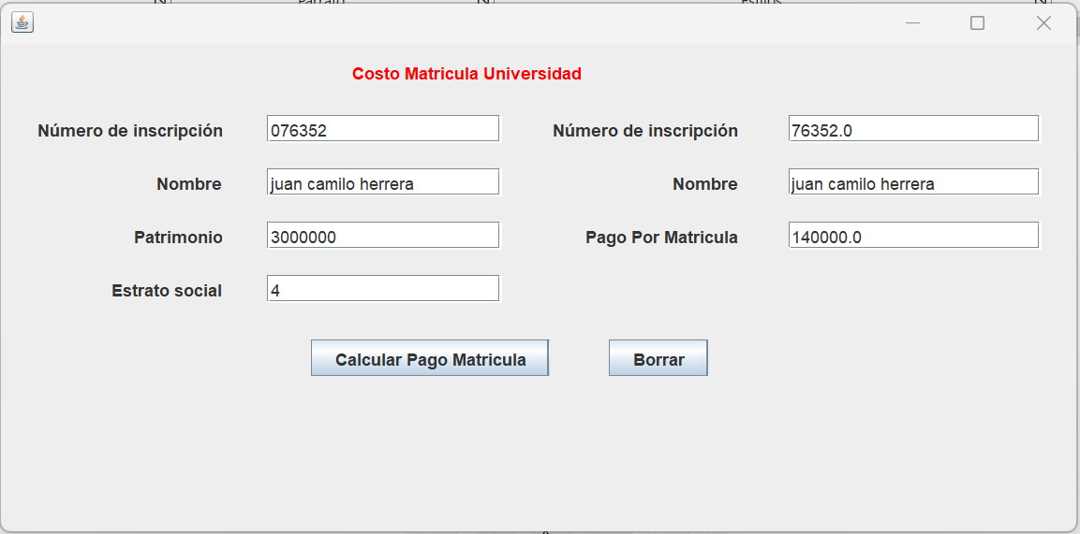

**Diagrama UML**

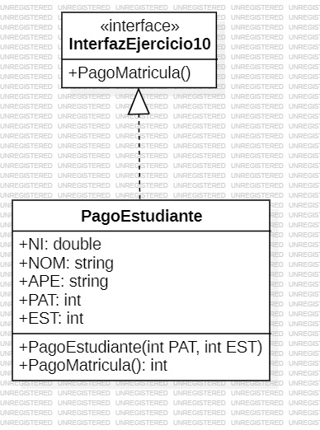

**Links:** <https://github.com/juancoficial7/actividad3/tree/main/EjercicioRes_10>

**Ejercicio propuesto # 22**

**Clase Empleado1**

package ejercicioprop_22;

class Empleado1 {

String NOMBRE;

double SAL_HORA;

double HORA_TRAB;

public Empleado1(String NOMBRE, double SAL_HORA, double HORA_TRAB) {

this.NOMBRE = NOMBRE;

this.SAL_HORA = SAL_HORA;

this.HORA_TRAB = HORA_TRAB;

}

public double calcularSalarioMensual() {

double SALARIO_MEN = SAL_HORA * HORA_TRAB;

return SALARIO_MEN;

}

}

**Void main EjercicioProp_22**

package ejercicioprop_22;

public class EjercicioProp_22 {

public static void main(String[] args) {

InterfazEjercicioProp_22 matricula = new InterfazEjercicioProp_22();

matricula.show(true);

}

}

**Interfaz Grafica**

package ejercicioprop_22;

public class InterfazEjercicioProp_22 extends javax.swing.JFrame {

public InterfazEjercicioProp_22() {

initComponents();

}

@SuppressWarnings("unchecked")

// <editor-fold defaultstate="collapsed" desc="Generated Code">

private void initComponents() {

jLabel1 = new javax.swing.JLabel();

jLabel2 = new javax.swing.JLabel();

jLabel3 = new javax.swing.JLabel();

jLabel4 = new javax.swing.JLabel();

txtNombre = new javax.swing.JTextField();

txtSalario = new javax.swing.JTextField();

txtHTrabajadas = new javax.swing.JTextField();

jLabel5 = new javax.swing.JLabel();

txtResultado = new javax.swing.JTextField();

btnResultado = new javax.swing.JButton();

btnBorrar = new javax.swing.JButton();

setDefaultCloseOperation(javax.swing.WindowConstants.EXIT_ON_CLOSE);

jLabel1.setForeground(new java.awt.Color(255, 0, 0));

jLabel1.setText("Empleado");

jLabel2.setText("Nombre");

jLabel3.setText("Salario");

jLabel4.setText("Horas trabajadas");

txtNombre.addActionListener(new java.awt.event.ActionListener() {

public void actionPerformed(java.awt.event.ActionEvent evt) {

txtNombreActionPerformed(evt);

}

});

jLabel5.setText("Resultado");

btnResultado.setText("Calcular Resultado");

btnResultado.addActionListener(new java.awt.event.ActionListener() {

public void actionPerformed(java.awt.event.ActionEvent evt) {

btnResultadoActionPerformed(evt);

}

});

btnBorrar.setText("Borrar");

btnBorrar.addActionListener(new java.awt.event.ActionListener() {

public void actionPerformed(java.awt.event.ActionEvent evt) {

btnBorrarActionPerformed(evt);

}

});

javax.swing.GroupLayout layout = new javax.swing.GroupLayout(getContentPane());

getContentPane().setLayout(layout);

layout.setHorizontalGroup(

layout.createParallelGroup(javax.swing.GroupLayout.Alignment.LEADING)

.addGroup(javax.swing.GroupLayout.Alignment.TRAILING, layout.createSequentialGroup()

.addContainerGap(javax.swing.GroupLayout.DEFAULT_SIZE, Short.MAX_VALUE)

.addComponent(jLabel1)

.addGap(261, 261, 261))

.addGroup(layout.createSequentialGroup()

.addGap(16, 16, 16)

.addGroup(layout.createParallelGroup(javax.swing.GroupLayout.Alignment.TRAILING)

.addComponent(jLabel5)

.addComponent(jLabel4)

.addComponent(jLabel3)

.addComponent(jLabel2))

.addGap(29, 29, 29)

.addGroup(layout.createParallelGroup(javax.swing.GroupLayout.Alignment.LEADING)

.addGroup(layout.createSequentialGroup()

.addComponent(btnResultado)

.addGap(41, 41, 41)

.addComponent(btnBorrar))

.addGroup(layout.createParallelGroup(javax.swing.GroupLayout.Alignment.LEADING, false)

.addComponent(txtNombre)

.addComponent(txtSalario)

.addComponent(txtHTrabajadas, javax.swing.GroupLayout.DEFAULT_SIZE, 170, Short.MAX_VALUE))

.addComponent(txtResultado, javax.swing.GroupLayout.PREFERRED_SIZE, 417, javax.swing.GroupLayout.PREFERRED_SIZE))

.addContainerGap(31, Short.MAX_VALUE))

);

layout.setVerticalGroup(

layout.createParallelGroup(javax.swing.GroupLayout.Alignment.LEADING)

.addGroup(layout.createSequentialGroup()

.addContainerGap()

.addComponent(jLabel1)

.addGap(21, 21, 21)

.addGroup(layout.createParallelGroup(javax.swing.GroupLayout.Alignment.BASELINE)

.addComponent(jLabel2)

.addComponent(txtNombre, javax.swing.GroupLayout.PREFERRED_SIZE, javax.swing.GroupLayout.DEFAULT_SIZE, javax.swing.GroupLayout.PREFERRED_SIZE))

.addGap(18, 18, 18)

.addGroup(layout.createParallelGroup(javax.swing.GroupLayout.Alignment.BASELINE)

.addComponent(jLabel3)

.addComponent(txtSalario, javax.swing.GroupLayout.PREFERRED_SIZE, javax.swing.GroupLayout.DEFAULT_SIZE, javax.swing.GroupLayout.PREFERRED_SIZE))

.addGap(18, 18, 18)

.addGroup(layout.createParallelGroup(javax.swing.GroupLayout.Alignment.BASELINE)

.addComponent(jLabel4)

.addComponent(txtHTrabajadas, javax.swing.GroupLayout.PREFERRED_SIZE, javax.swing.GroupLayout.DEFAULT_SIZE, javax.swing.GroupLayout.PREFERRED_SIZE))

.addGap(18, 18, 18)

.addGroup(layout.createParallelGroup(javax.swing.GroupLayout.Alignment.BASELINE)

.addComponent(jLabel5)

.addComponent(txtResultado, javax.swing.GroupLayout.PREFERRED_SIZE, javax.swing.GroupLayout.DEFAULT_SIZE, javax.swing.GroupLayout.PREFERRED_SIZE))

.addGap(33, 33, 33)

.addGroup(layout.createParallelGroup(javax.swing.GroupLayout.Alignment.BASELINE)

.addComponent(btnResultado)

.addComponent(btnBorrar))

.addContainerGap(97, Short.MAX_VALUE))

);

pack();

}// </editor-fold>

private void txtNombreActionPerformed(java.awt.event.ActionEvent evt) {

// TODO add your handling code here:

}

private void btnResultadoActionPerformed(java.awt.event.ActionEvent evt) {

double salarioMensual;

String nombre = txtNombre.getText();

double salarioHora = Double.parseDouble(txtSalario.getText());

int horasTrabajadas = Integer.parseInt(txtHTrabajadas.getText());

Empleado1 trabajador = new Empleado1(nombre, salarioHora, horasTrabajadas);

salarioMensual = trabajador.calcularSalarioMensual();

if (salarioMensual > 450000) {

txtResultado.setText("Nombre del empleado: " + nombre + " - Salario mensual: $" + salarioMensual);

} else {

txtResultado.setText("Nombre del empleado: " + nombre);

}

}

private void btnBorrarActionPerformed(java.awt.event.ActionEvent evt) {

txtNombre.setText("");

txtSalario.setText("");

txtHTrabajadas.setText("");

txtResultado.setText("");

}

/**

* @param args the command line arguments

*/

public static void main(String args[]) {

/* Set the Nimbus look and feel */

//<editor-fold defaultstate="collapsed" desc=" Look and feel setting code (optional) ">

/* If Nimbus (introduced in Java SE 6) is not available, stay with the default look and feel.

* For details see http://download.oracle.com/javase/tutorial/uiswing/lookandfeel/plaf.html

*/

try {

for (javax.swing.UIManager.LookAndFeelInfo info : javax.swing.UIManager.getInstalledLookAndFeels()) {

if ("Nimbus".equals(info.getName())) {

javax.swing.UIManager.setLookAndFeel(info.getClassName());

break;

}

}

} catch (ClassNotFoundException ex) {

java.util.logging.Logger.getLogger(InterfazEjercicioProp_22.class.getName()).log(java.util.logging.Level.SEVERE, null, ex);

} catch (InstantiationException ex) {

java.util.logging.Logger.getLogger(InterfazEjercicioProp_22.class.getName()).log(java.util.logging.Level.SEVERE, null, ex);

} catch (IllegalAccessException ex) {

java.util.logging.Logger.getLogger(InterfazEjercicioProp_22.class.getName()).log(java.util.logging.Level.SEVERE, null, ex);

} catch (javax.swing.UnsupportedLookAndFeelException ex) {

java.util.logging.Logger.getLogger(InterfazEjercicioProp_22.class.getName()).log(java.util.logging.Level.SEVERE, null, ex);

}

//</editor-fold>

/* Create and display the form */

java.awt.EventQueue.invokeLater(new Runnable() {

public void run() {

new InterfazEjercicioProp_22().setVisible(true);

}

});

}

// Variables declaration - do not modify

private javax.swing.JButton btnBorrar;

private javax.swing.JButton btnResultado;

private javax.swing.JLabel jLabel1;

private javax.swing.JLabel jLabel2;

private javax.swing.JLabel jLabel3;

private javax.swing.JLabel jLabel4;

private javax.swing.JLabel jLabel5;

private javax.swing.JTextField txtHTrabajadas;

private javax.swing.JTextField txtNombre;

private javax.swing.JTextField txtResultado;

private javax.swing.JTextField txtSalario;

// End of variables declaration

}

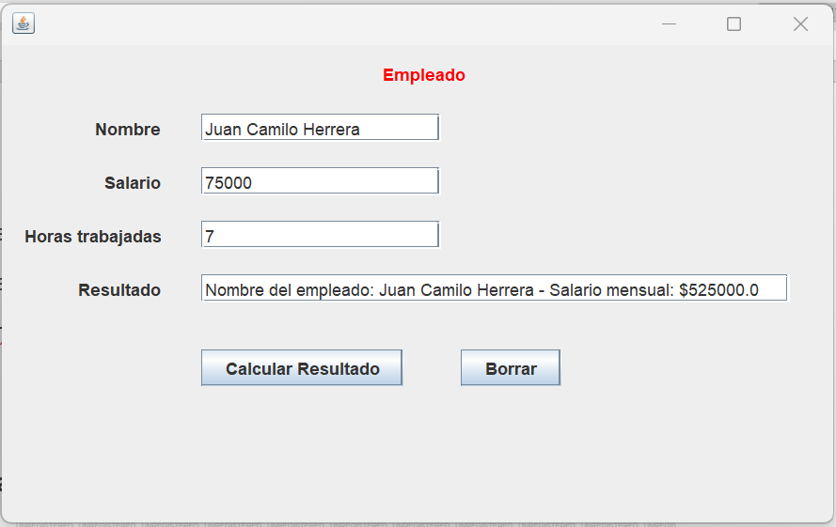

**Diagrama UML**

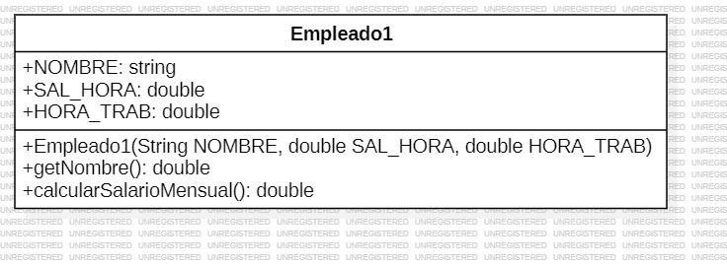

**Links:** <https://github.com/juancoficial7/actividad3/tree/main/EjercicioProp_22>

**Ejercicio propuesto # 23**

**Interfaz de consola enterfazEjercicio23**

package ejercicioprop_23;

public interface enterfazEjercicio23 {

double D(double A, double B, double C);

}

**Clase Ecuacion**

package ejercicioprop_23;

public class Ecuacion implements enterfazEjercicio23 {

private final double A;

private final double B;

private final double C;

public Ecuacion(double A, double B, double C) {

this.A = A;

this.B = B;

this.C = C;

}

@Override

public double D(double A, double B, double C){

return (Math.pow(B, 2) - 4*A*C);

}

}

**Void main EjercicioProp_23**

package ejercicioprop_23;

public class EjercicioProp_23 {

public static void main(String[] args) {

InterfazEjercicioProp_23 ecuacion = new InterfazEjercicioProp_23();

ecuacion.show(true);

}

}

**Interfaz Grafica**

package ejercicioprop_23;

public class InterfazEjercicioProp_23 extends javax.swing.JFrame {

public InterfazEjercicioProp_23() {

initComponents();

}

@SuppressWarnings("unchecked")

// <editor-fold defaultstate="collapsed" desc="Generated Code">

private void initComponents() {

jLabel1 = new javax.swing.JLabel();

jLabel2 = new javax.swing.JLabel();

jLabel3 = new javax.swing.JLabel();

jLabel4 = new javax.swing.JLabel();

txtValorA = new javax.swing.JTextField();

txtValorB = new javax.swing.JTextField();

txtValorC = new javax.swing.JTextField();

jLabel5 = new javax.swing.JLabel();

txtSoluciones = new javax.swing.JTextField();

btnCalcularSolucion = new javax.swing.JButton();

btnBorrar = new javax.swing.JButton();

setDefaultCloseOperation(javax.swing.WindowConstants.EXIT_ON_CLOSE);

jLabel1.setForeground(new java.awt.Color(255, 0, 0));

jLabel1.setText("Ecuacion de Segundo Grado");

jLabel2.setText("Valor de A");

jLabel3.setText("Valor de B");

jLabel4.setText("Valor de C");

jLabel5.setText("Soluciones");

btnCalcularSolucion.setText("Calcular Soluciones");

btnCalcularSolucion.addActionListener(new java.awt.event.ActionListener() {

public void actionPerformed(java.awt.event.ActionEvent evt) {

btnCalcularSolucionActionPerformed(evt);

}

});

btnBorrar.setText("Borrar");

btnBorrar.addActionListener(new java.awt.event.ActionListener() {

public void actionPerformed(java.awt.event.ActionEvent evt) {

btnBorrarActionPerformed(evt);

}

});

javax.swing.GroupLayout layout = new javax.swing.GroupLayout(getContentPane());

getContentPane().setLayout(layout);

layout.setHorizontalGroup(

layout.createParallelGroup(javax.swing.GroupLayout.Alignment.LEADING)

.addGroup(layout.createSequentialGroup()

.addGap(48, 48, 48)

.addGroup(layout.createParallelGroup(javax.swing.GroupLayout.Alignment.TRAILING)

.addComponent(jLabel3)

.addComponent(jLabel2)

.addComponent(jLabel4)

.addComponent(jLabel5))

.addGap(31, 31, 31)

.addGroup(layout.createParallelGroup(javax.swing.GroupLayout.Alignment.LEADING)

.addComponent(txtSoluciones)

.addGroup(layout.createSequentialGroup()

.addGroup(layout.createParallelGroup(javax.swing.GroupLayout.Alignment.LEADING)

.addGroup(layout.createParallelGroup(javax.swing.GroupLayout.Alignment.LEADING, false)

.addComponent(txtValorA, javax.swing.GroupLayout.DEFAULT_SIZE, 157, Short.MAX_VALUE)

.addComponent(txtValorB)

.addComponent(txtValorC))

.addGroup(layout.createSequentialGroup()

.addGap(63, 63, 63)

.addComponent(btnCalcularSolucion)

.addGap(36, 36, 36)

.addComponent(btnBorrar)))

.addGap(0, 179, Short.MAX_VALUE)))

.addContainerGap())

.addGroup(javax.swing.GroupLayout.Alignment.TRAILING, layout.createSequentialGroup()

.addContainerGap(javax.swing.GroupLayout.DEFAULT_SIZE, Short.MAX_VALUE)

.addComponent(jLabel1)

.addGap(223, 223, 223))

);

layout.setVerticalGroup(

layout.createParallelGroup(javax.swing.GroupLayout.Alignment.LEADING)

.addGroup(layout.createSequentialGroup()

.addContainerGap()

.addComponent(jLabel1)

.addGap(18, 18, 18)

.addGroup(layout.createParallelGroup(javax.swing.GroupLayout.Alignment.BASELINE)

.addComponent(jLabel2)

.addComponent(txtValorA, javax.swing.GroupLayout.PREFERRED_SIZE, javax.swing.GroupLayout.DEFAULT_SIZE, javax.swing.GroupLayout.PREFERRED_SIZE))

.addGap(18, 18, 18)

.addGroup(layout.createParallelGroup(javax.swing.GroupLayout.Alignment.BASELINE)

.addComponent(jLabel3)

.addComponent(txtValorB, javax.swing.GroupLayout.PREFERRED_SIZE, javax.swing.GroupLayout.DEFAULT_SIZE, javax.swing.GroupLayout.PREFERRED_SIZE))

.addGap(18, 18, 18)

.addGroup(layout.createParallelGroup(javax.swing.GroupLayout.Alignment.BASELINE)

.addComponent(jLabel4)

.addComponent(txtValorC, javax.swing.GroupLayout.PREFERRED_SIZE, javax.swing.GroupLayout.DEFAULT_SIZE, javax.swing.GroupLayout.PREFERRED_SIZE))

.addGap(18, 18, 18)

.addGroup(layout.createParallelGroup(javax.swing.GroupLayout.Alignment.BASELINE)

.addComponent(jLabel5)

.addComponent(txtSoluciones, javax.swing.GroupLayout.PREFERRED_SIZE, javax.swing.GroupLayout.DEFAULT_SIZE, javax.swing.GroupLayout.PREFERRED_SIZE))

.addGap(27, 27, 27)

.addGroup(layout.createParallelGroup(javax.swing.GroupLayout.Alignment.BASELINE)

.addComponent(btnCalcularSolucion)

.addComponent(btnBorrar))

.addContainerGap(49, Short.MAX_VALUE))

);

pack();

}// </editor-fold>

private void btnCalcularSolucionActionPerformed(java.awt.event.ActionEvent evt) {

double discriminante;

double valorA = Double.parseDouble(txtValorA.getText());

double valorB = Double.parseDouble(txtValorB.getText());

double valorC = Double.parseDouble(txtValorC.getText());

Ecuacion resultado = new Ecuacion(valorA, valorB, valorC);

discriminante = resultado.D(valorC, valorB, valorC);

if (discriminante >= 0) {

double x1 = (-valorB + Math.sqrt(discriminante) / (2*valorA));

double x2 = (-valorB - Math.sqrt(discriminante) / (2*valorA));

txtSoluciones.setText("La primera solución es "+x1+ " y "+x2);

} else {

txtSoluciones.setText("La ecuación no tiene soluciones reales");

}

}

private void btnBorrarActionPerformed(java.awt.event.ActionEvent evt) {

txtValorA.setText("");

txtValorB.setText("");

txtValorC.setText("");

txtSoluciones.setText("");

}

/**

* @param args the command line arguments

*/

public static void main(String args[]) {

/* Set the Nimbus look and feel */

//<editor-fold defaultstate="collapsed" desc=" Look and feel setting code (optional) ">

/* If Nimbus (introduced in Java SE 6) is not available, stay with the default look and feel.

* For details see http://download.oracle.com/javase/tutorial/uiswing/lookandfeel/plaf.html

*/

try {

for (javax.swing.UIManager.LookAndFeelInfo info : javax.swing.UIManager.getInstalledLookAndFeels()) {

if ("Nimbus".equals(info.getName())) {

javax.swing.UIManager.setLookAndFeel(info.getClassName());

break;

}

}

} catch (ClassNotFoundException ex) {

java.util.logging.Logger.getLogger(InterfazEjercicioProp_23.class.getName()).log(java.util.logging.Level.SEVERE, null, ex);

} catch (InstantiationException ex) {

java.util.logging.Logger.getLogger(InterfazEjercicioProp_23.class.getName()).log(java.util.logging.Level.SEVERE, null, ex);

} catch (IllegalAccessException ex) {

java.util.logging.Logger.getLogger(InterfazEjercicioProp_23.class.getName()).log(java.util.logging.Level.SEVERE, null, ex);

} catch (javax.swing.UnsupportedLookAndFeelException ex) {

java.util.logging.Logger.getLogger(InterfazEjercicioProp_23.class.getName()).log(java.util.logging.Level.SEVERE, null, ex);

}

//</editor-fold>

/* Create and display the form */

java.awt.EventQueue.invokeLater(new Runnable() {

public void run() {

new InterfazEjercicioProp_23().setVisible(true);

}

});

}

// Variables declaration - do not modify

private javax.swing.JButton btnBorrar;

private javax.swing.JButton btnCalcularSolucion;

private javax.swing.JLabel jLabel1;

private javax.swing.JLabel jLabel2;

private javax.swing.JLabel jLabel3;

private javax.swing.JLabel jLabel4;

private javax.swing.JLabel jLabel5;

private javax.swing.JTextField txtSoluciones;

private javax.swing.JTextField txtValorA;

private javax.swing.JTextField txtValorB;

private javax.swing.JTextField txtValorC;

// End of variables declaration

}

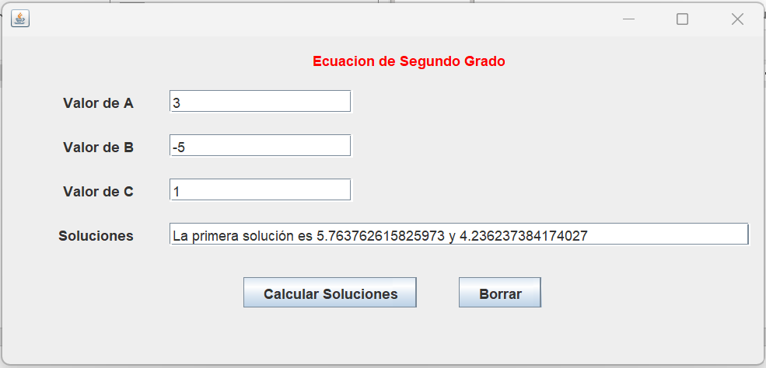

**Diagrama UML**

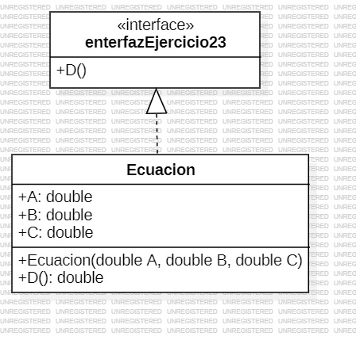

**Links:** [**https://github.com/juancoficial7/actividad3/tree/main/EjercicioProp_23**](https://github.com/juancoficial7/actividad3/tree/main/EjercicioProp_23)

**Ejercicio Figuras**

**Interfaz de consola InterfazFiguras**

package Figuras;

public interface InterfazFiguras {

double calcularArea();

double calcularPerimetro();

double calcularHipotenusa();

}

**Clase circulo**

package Figuras;

public class Circulo implements InterfazFiguras{

int radio; // Atributo que define el radio de un círculo

/**

* Constructor de la clase Círculo

* @param radio Parámetro que define el radio de un círculo

*/

Circulo(int radio){

this.radio = radio;

}

/**

* Método que calcula y devuelve el área de un círculo como pi

* multiplicado por el radio al cuadrado

* @return Área de un círculo

*/

@Override

public double calcularArea() {

return Math.PI*Math.pow(radio,2);

}

/**

* Método que calcula y devuelve el perímetro de un círculo como la

* multiplicación de pi por el radio por 2

* @return Perímetro de un círculo

*/

@Override

public double calcularPerimetro() {

return 2*Math.PI*radio;

}

@Override

public double calcularHipotenusa() {

throw new UnsupportedOperationException("Not supported yet."); // Generated from nbfs://nbhost/SystemFileSystem/Templates/Classes/Code/GeneratedMethodBody

}

}

**Clase cuadrado**

package Figuras;

public class Cuadrado implements InterfazFiguras{

int lado; // Atributo que define el lado de un cuadrado

/**

* Constructor de la clase Cuadrado

* @param lado Parámetro que define la longitud de la base de un

* cuadrado

*/

public Cuadrado(int lado) {

this.lado = lado;

}

/**

* Método que calcula y devuelve el área de un cuadrado como el

* lado elevado al cuadrado

* @return Área de un Cuadrado

*/

@Override

public double calcularArea() {

return lado*lado;

}

/**

* Método que calcula y devuelve el perímetro de un cuadrado como

* cuatro veces su lado

* @return Perímetro de un cuadrado

*/

@Override

public double calcularPerimetro() {

return (4*lado);

}

@Override

public double calcularHipotenusa() {

throw new UnsupportedOperationException("Not supported yet."); // Generated from nbfs://nbhost/SystemFileSystem/Templates/Classes/Code/GeneratedMethodBody

}

}

**Clase rectángulo**

package Figuras;

public class Rectangulo implements InterfazFiguras {

int base; // Atributo que define la base de un rectángulo

int altura; // Atributo que define la altura de un rectángulo

/**

* Constructor de la clase Rectangulo

* @param base Parámetro que define la base de un rectángulo

* @param altura Parámetro que define la altura de un rectángulo

*/

Rectangulo(int base, int altura) {

this.base = base;

this.altura = altura;

}

/**

* Método que calcula y devuelve el área de un rectángulo como la

* multiplicación de la base por la altura

* @return Área de un rectángulo

*/

@Override

public double calcularArea() {

return base * altura;

}

/**

* Método que calcula y devuelve el perímetro de un rectángulo

* como (2 * base) + (2 * altura)

* @return Perímetro de un rectángulo

*/

@Override

public double calcularPerimetro() {

return (2 * base) + (2 * altura);

}

@Override

public double calcularHipotenusa() {

throw new UnsupportedOperationException("Not supported yet."); // Generated from nbfs://nbhost/SystemFileSystem/Templates/Classes/Code/GeneratedMethodBody

}

}

**Clase TrianguloRectangulo**

package Figuras;

public class TrianguloRectangulo implements InterfazFiguras{

int base; // Atributo que define la base de un triángulo rectángulo

int altura; // Atributo que define la altura de un triángulo rectángulo

/**

* Constructor de la clase TrianguloRectangulo

* @param base Parámetro que define la base de un triángulo

* rectángulo

* @param altura Parámetro que define la altura de un triángulo

* rectángulo

*/

public TrianguloRectangulo(int base, int altura) {

this.base = base;

this.altura = altura;

}

/**

* Método que calcula y devuelve el área de un triángulo rectángulo

* como la base multiplicada por la altura sobre 2

* @return Área de un triángulo rectángulo

*/

@Override

public double calcularArea() {

return (base * altura / 2);

}

/**

* Método que calcula y devuelve el perímetro de un triángulo

* rectángulo como la suma de la base, la altura y la hipotenusa

* @return Perimetro de un triángulo rectángulo

*/

@Override

public double calcularPerimetro() {

return (base + altura + calcularHipotenusa()); /* Invoca al

método calcular hipotenusa */

}

/**

* Método que calcula y devuelve la hipotenusa de un triángulo

* rectángulo utilizando el teorema de Pitágoras

* @return Hipotenusa de un triángulo rectángulo

*/

@Override

public double calcularHipotenusa() {

return Math.pow(base*base + altura*altura, 0.5);

}

/**

* Método que determina si un triángulo es:

* - Equilatero: si sus tres lados son iguales

* - Escaleno: si sus tres lados son todos diferentes

* - Escaleno: si dos de sus lados son iguales y el otro es diferente de

* los demás

*/

String determinarTipoTriangulo() {

if ((base == altura) && (base == calcularHipotenusa()) && (altura == calcularHipotenusa()))

return "Es un triángulo equilátero"; /* Todos sus lados son iguales */

else if ((base != altura) && (base != calcularHipotenusa()) && (altura != calcularHipotenusa()))

return "Es un triángulo escaleno"; /* Todos sus lados son diferentes */

else

return "Es un triángulo isósceles"; /* De otra manera, es isósceles */

}

}

**Void main PruebaFiguras**

package Figuras;

public class PruebaFiguras {

public static void main(String[] args) {

VentanaPrincipal ventana = new VentanaPrincipal();

ventana.show(true);

}

}

**Interfaz Grafica**

package Figuras;

public class VentanaPrincipal extends javax.swing.JFrame {

public VentanaPrincipal() {

initComponents();

}

@SuppressWarnings("unchecked")

// <editor-fold defaultstate="collapsed" desc="Generated Code">

private void initComponents() {

jLabel1 = new javax.swing.JLabel();

jLabel2 = new javax.swing.JLabel();

jLabel3 = new javax.swing.JLabel();

jLabel4 = new javax.swing.JLabel();

txtCRadio = new javax.swing.JTextField();

txtCArea = new javax.swing.JTextField();

txtCPerimetro = new javax.swing.JTextField();

btnArea = new javax.swing.JButton();

btnPerimetro = new javax.swing.JButton();

btnBorrar = new javax.swing.JButton();

jLabel5 = new javax.swing.JLabel();

jLabel6 = new javax.swing.JLabel();

jLabel7 = new javax.swing.JLabel();

jLabel8 = new javax.swing.JLabel();

txtCuLado = new javax.swing.JTextField();

txtCuArea = new javax.swing.JTextField();

txtCuPerimetro = new javax.swing.JTextField();

btnCuArea = new javax.swing.JButton();

btnCuPerimetro = new javax.swing.JButton();

btnCuBorrar = new javax.swing.JButton();

jLabel9 = new javax.swing.JLabel();

jLabel10 = new javax.swing.JLabel();

jLabel11 = new javax.swing.JLabel();

jLabel12 = new javax.swing.JLabel();

jLabel13 = new javax.swing.JLabel();

txtRAltura = new javax.swing.JTextField();

txtRArea = new javax.swing.JTextField();

txtRPerimetro = new javax.swing.JTextField();

btnRArea = new javax.swing.JButton();

btnRperimetro = new javax.swing.JButton();

btnRBorrar = new javax.swing.JButton();

txtRBase = new javax.swing.JTextField();

jLabel14 = new javax.swing.JLabel();

jLabel15 = new javax.swing.JLabel();

jLabel16 = new javax.swing.JLabel();

jLabel17 = new javax.swing.JLabel();

jLabel18 = new javax.swing.JLabel();

jLabel19 = new javax.swing.JLabel();

jLabel20 = new javax.swing.JLabel();

txtTRBase = new javax.swing.JTextField();

txtTRAltura = new javax.swing.JTextField();

txtTRArea = new javax.swing.JTextField();

txtTRPerimetro = new javax.swing.JTextField();

txtTRHipotenusa = new javax.swing.JTextField();

txtTRTriangulo = new javax.swing.JTextField();

btnTRArea = new javax.swing.JButton();

btnTRPerimetro = new javax.swing.JButton();

btnTRHipotenusa = new javax.swing.JButton();

btnTRTriangulo = new javax.swing.JButton();

btnTRBorrar = new javax.swing.JButton();

setDefaultCloseOperation(javax.swing.WindowConstants.EXIT_ON_CLOSE);

jLabel1.setForeground(new java.awt.Color(255, 0, 0));

jLabel1.setText("Circulo");

jLabel2.setText("Radio");

jLabel3.setText("Area");

jLabel4.setText("Perimetro");

txtCRadio.addActionListener(new java.awt.event.ActionListener() {

public void actionPerformed(java.awt.event.ActionEvent evt) {

txtCRadioActionPerformed(evt);

}

});

btnArea.setText("Calcular Area");

btnArea.addActionListener(new java.awt.event.ActionListener() {

public void actionPerformed(java.awt.event.ActionEvent evt) {

btnAreaActionPerformed(evt);

}

});

btnPerimetro.setText("Calcular Perimetro");

btnPerimetro.addActionListener(new java.awt.event.ActionListener() {

public void actionPerformed(java.awt.event.ActionEvent evt) {

btnPerimetroActionPerformed(evt);

}

});

btnBorrar.setText("Borrar");

btnBorrar.addActionListener(new java.awt.event.ActionListener() {

public void actionPerformed(java.awt.event.ActionEvent evt) {

btnBorrarActionPerformed(evt);

}

});

jLabel5.setForeground(new java.awt.Color(255, 0, 0));

jLabel5.setText("Cuadrado");

jLabel6.setText("Lado");

jLabel7.setText("Area");

jLabel8.setText("Perimetro");

txtCuArea.addActionListener(new java.awt.event.ActionListener() {

public void actionPerformed(java.awt.event.ActionEvent evt) {

txtCuAreaActionPerformed(evt);

}

});

txtCuPerimetro.addActionListener(new java.awt.event.ActionListener() {

public void actionPerformed(java.awt.event.ActionEvent evt) {

txtCuPerimetroActionPerformed(evt);

}

});

btnCuArea.setText("Calcular Area");

btnCuArea.addActionListener(new java.awt.event.ActionListener() {

public void actionPerformed(java.awt.event.ActionEvent evt) {

btnCuAreaActionPerformed(evt);

}

});

btnCuPerimetro.setText("Calcular Perimetro");

btnCuPerimetro.addActionListener(new java.awt.event.ActionListener() {

public void actionPerformed(java.awt.event.ActionEvent evt) {

btnCuPerimetroActionPerformed(evt);

}

});

btnCuBorrar.setText("Borrar");

btnCuBorrar.addActionListener(new java.awt.event.ActionListener() {

public void actionPerformed(java.awt.event.ActionEvent evt) {

btnCuBorrarActionPerformed(evt);

}

});

jLabel9.setForeground(new java.awt.Color(255, 0, 0));

jLabel9.setText("Rectangulo");

jLabel10.setText("Base");

jLabel11.setText("Altura");

jLabel12.setText("Area");

jLabel13.setText("Perimetro");

txtRArea.addActionListener(new java.awt.event.ActionListener() {

public void actionPerformed(java.awt.event.ActionEvent evt) {

txtRAreaActionPerformed(evt);

}

});

txtRPerimetro.addActionListener(new java.awt.event.ActionListener() {

public void actionPerformed(java.awt.event.ActionEvent evt) {

txtRPerimetroActionPerformed(evt);

}

});

btnRArea.setText("Calcular Area");

btnRArea.addActionListener(new java.awt.event.ActionListener() {

public void actionPerformed(java.awt.event.ActionEvent evt) {

btnRAreaActionPerformed(evt);

}

});

btnRperimetro.setText("Calcular Perimetro");

btnRperimetro.addActionListener(new java.awt.event.ActionListener() {

public void actionPerformed(java.awt.event.ActionEvent evt) {

btnRperimetroActionPerformed(evt);

}

});

btnRBorrar.setText("Borrar");

btnRBorrar.addActionListener(new java.awt.event.ActionListener() {

public void actionPerformed(java.awt.event.ActionEvent evt) {

btnRBorrarActionPerformed(evt);

}

});

jLabel14.setForeground(new java.awt.Color(255, 0, 0));

jLabel14.setText("Triangulo Rectangulo");

jLabel15.setText("Base");

jLabel16.setText("Altura");

jLabel17.setText("Area");

jLabel18.setText("Perimetro");

jLabel19.setText("Hipotenusa");

jLabel20.setText("Tipo Triangulo");

btnTRArea.setText("Area");

btnTRArea.addActionListener(new java.awt.event.ActionListener() {

public void actionPerformed(java.awt.event.ActionEvent evt) {

btnTRAreaActionPerformed(evt);

}

});

btnTRPerimetro.setText("Perimetro");

btnTRPerimetro.addActionListener(new java.awt.event.ActionListener() {

public void actionPerformed(java.awt.event.ActionEvent evt) {

btnTRPerimetroActionPerformed(evt);

}

});

btnTRHipotenusa.setText("Hipotenusa");

btnTRHipotenusa.addActionListener(new java.awt.event.ActionListener() {

public void actionPerformed(java.awt.event.ActionEvent evt) {

btnTRHipotenusaActionPerformed(evt);

}

});

btnTRTriangulo.setText("Tipo Triangulo");

btnTRTriangulo.addActionListener(new java.awt.event.ActionListener() {

public void actionPerformed(java.awt.event.ActionEvent evt) {

btnTRTrianguloActionPerformed(evt);

}

});

btnTRBorrar.setText("Borrar");

btnTRBorrar.addActionListener(new java.awt.event.ActionListener() {

public void actionPerformed(java.awt.event.ActionEvent evt) {

btnTRBorrarActionPerformed(evt);

}

});

javax.swing.GroupLayout layout = new javax.swing.GroupLayout(getContentPane());

getContentPane().setLayout(layout);

layout.setHorizontalGroup(

layout.createParallelGroup(javax.swing.GroupLayout.Alignment.LEADING)

.addGroup(javax.swing.GroupLayout.Alignment.TRAILING, layout.createSequentialGroup()

.addGap(39, 39, 39)

.addGroup(layout.createParallelGroup(javax.swing.GroupLayout.Alignment.LEADING)

.addGroup(layout.createSequentialGroup()

.addGroup(layout.createParallelGroup(javax.swing.GroupLayout.Alignment.TRAILING)

.addGroup(layout.createSequentialGroup()

.addComponent(btnRArea, javax.swing.GroupLayout.DEFAULT_SIZE, javax.swing.GroupLayout.DEFAULT_SIZE, Short.MAX_VALUE)

.addPreferredGap(javax.swing.LayoutStyle.ComponentPlacement.UNRELATED)

.addComponent(btnRperimetro)

.addGap(18, 18, 18)

.addComponent(btnRBorrar))

.addGroup(layout.createSequentialGroup()

.addGroup(layout.createParallelGroup(javax.swing.GroupLayout.Alignment.TRAILING)

.addGroup(layout.createSequentialGroup()

.addComponent(jLabel9)

.addGap(25, 25, 25))

.addGroup(layout.createSequentialGroup()

.addComponent(btnArea, javax.swing.GroupLayout.DEFAULT_SIZE, javax.swing.GroupLayout.DEFAULT_SIZE, Short.MAX_VALUE)

.addPreferredGap(javax.swing.LayoutStyle.ComponentPlacement.UNRELATED)

.addComponent(btnPerimetro)

.addPreferredGap(javax.swing.LayoutStyle.ComponentPlacement.UNRELATED)))

.addComponent(btnBorrar)))

.addGap(95, 95, 95))

.addGroup(layout.createSequentialGroup()

.addGap(157, 157, 157)

.addComponent(jLabel1, javax.swing.GroupLayout.PREFERRED_SIZE, 46, javax.swing.GroupLayout.PREFERRED_SIZE))

.addGroup(layout.createSequentialGroup()

.addGap(20, 20, 20)

.addGroup(layout.createParallelGroup(javax.swing.GroupLayout.Alignment.LEADING, false)

.addGroup(layout.createSequentialGroup()

.addComponent(jLabel13)

.addPreferredGap(javax.swing.LayoutStyle.ComponentPlacement.RELATED, javax.swing.GroupLayout.DEFAULT_SIZE, Short.MAX_VALUE)

.addComponent(txtRPerimetro, javax.swing.GroupLayout.PREFERRED_SIZE, 222, javax.swing.GroupLayout.PREFERRED_SIZE))

.addGroup(javax.swing.GroupLayout.Alignment.TRAILING, layout.createSequentialGroup()

.addComponent(jLabel12)

.addPreferredGap(javax.swing.LayoutStyle.ComponentPlacement.RELATED, javax.swing.GroupLayout.DEFAULT_SIZE, Short.MAX_VALUE)

.addComponent(txtRArea, javax.swing.GroupLayout.PREFERRED_SIZE, 221, javax.swing.GroupLayout.PREFERRED_SIZE))

.addGroup(layout.createSequentialGroup()

.addComponent(jLabel11)

.addPreferredGap(javax.swing.LayoutStyle.ComponentPlacement.RELATED, javax.swing.GroupLayout.DEFAULT_SIZE, Short.MAX_VALUE)

.addComponent(txtRAltura, javax.swing.GroupLayout.PREFERRED_SIZE, 221, javax.swing.GroupLayout.PREFERRED_SIZE))

.addGroup(layout.createSequentialGroup()

.addComponent(jLabel10, javax.swing.GroupLayout.PREFERRED_SIZE, 31, javax.swing.GroupLayout.PREFERRED_SIZE)

.addGap(39, 39, 39)

.addComponent(txtRBase, javax.swing.GroupLayout.PREFERRED_SIZE, 221, javax.swing.GroupLayout.PREFERRED_SIZE))))

.addGroup(layout.createSequentialGroup()

.addGap(25, 25, 25)

.addGroup(layout.createParallelGroup(javax.swing.GroupLayout.Alignment.TRAILING, false)

.addGroup(javax.swing.GroupLayout.Alignment.LEADING, layout.createSequentialGroup()

.addComponent(jLabel4)

.addPreferredGap(javax.swing.LayoutStyle.ComponentPlacement.RELATED, javax.swing.GroupLayout.DEFAULT_SIZE, Short.MAX_VALUE)

.addComponent(txtCPerimetro, javax.swing.GroupLayout.PREFERRED_SIZE, 214, javax.swing.GroupLayout.PREFERRED_SIZE))

.addGroup(javax.swing.GroupLayout.Alignment.LEADING, layout.createSequentialGroup()

.addGroup(layout.createParallelGroup(javax.swing.GroupLayout.Alignment.LEADING)

.addComponent(jLabel3)

.addComponent(jLabel2))

.addGap(43, 43, 43)

.addGroup(layout.createParallelGroup(javax.swing.GroupLayout.Alignment.LEADING)

.addComponent(txtCRadio, javax.swing.GroupLayout.PREFERRED_SIZE, 215, javax.swing.GroupLayout.PREFERRED_SIZE)

.addComponent(txtCArea, javax.swing.GroupLayout.Alignment.TRAILING, javax.swing.GroupLayout.PREFERRED_SIZE, 215, javax.swing.GroupLayout.PREFERRED_SIZE))))))

.addGap(96, 96, 96)

.addGroup(layout.createParallelGroup(javax.swing.GroupLayout.Alignment.TRAILING)

.addGroup(layout.createParallelGroup(javax.swing.GroupLayout.Alignment.LEADING)

.addComponent(jLabel18)

.addComponent(jLabel19, javax.swing.GroupLayout.PREFERRED_SIZE, 75, javax.swing.GroupLayout.PREFERRED_SIZE)

.addComponent(jLabel16)

.addComponent(jLabel15)

.addComponent(jLabel17))

.addGroup(layout.createSequentialGroup()

.addGroup(layout.createParallelGroup(javax.swing.GroupLayout.Alignment.LEADING)

.addComponent(jLabel7)

.addComponent(jLabel6)

.addComponent(jLabel8))

.addGap(24, 24, 24))

.addComponent(jLabel20)

.addGroup(layout.createSequentialGroup()

.addComponent(btnCuArea)

.addGap(6, 6, 6)))

.addPreferredGap(javax.swing.LayoutStyle.ComponentPlacement.RELATED)

.addGroup(layout.createParallelGroup(javax.swing.GroupLayout.Alignment.LEADING)

.addGroup(layout.createParallelGroup(javax.swing.GroupLayout.Alignment.LEADING, false)

.addComponent(jLabel14)

.addComponent(txtTRBase)

.addComponent(txtTRAltura)

.addComponent(txtTRArea)

.addComponent(txtTRPerimetro)

.addComponent(txtTRHipotenusa)

.addComponent(txtCuLado)

.addComponent(txtCuArea)

.addComponent(txtCuPerimetro, javax.swing.GroupLayout.PREFERRED_SIZE, 186, javax.swing.GroupLayout.PREFERRED_SIZE)

.addGroup(layout.createSequentialGroup()

.addGap(20, 20, 20)

.addComponent(jLabel5))

.addComponent(txtTRTriangulo, javax.swing.GroupLayout.DEFAULT_SIZE, 220, Short.MAX_VALUE))

.addGroup(layout.createSequentialGroup()

.addGap(6, 6, 6)

.addComponent(btnCuPerimetro)

.addGap(18, 18, 18)

.addComponent(btnCuBorrar)))

.addGap(42, 42, 42))

.addGroup(javax.swing.GroupLayout.Alignment.TRAILING, layout.createSequentialGroup()

.addContainerGap(javax.swing.GroupLayout.DEFAULT_SIZE, Short.MAX_VALUE)

.addComponent(btnTRArea)

.addGap(18, 18, 18)

.addComponent(btnTRPerimetro)

.addGap(18, 18, 18)

.addComponent(btnTRHipotenusa)

.addGap(18, 18, 18)

.addComponent(btnTRTriangulo)

.addPreferredGap(javax.swing.LayoutStyle.ComponentPlacement.RELATED)

.addComponent(btnTRBorrar)

.addGap(21, 21, 21))

);

layout.setVerticalGroup(

layout.createParallelGroup(javax.swing.GroupLayout.Alignment.LEADING)

.addGroup(layout.createSequentialGroup()

.addContainerGap()

.addGroup(layout.createParallelGroup(javax.swing.GroupLayout.Alignment.LEADING)

.addGroup(layout.createSequentialGroup()

.addComponent(jLabel5)

.addGap(18, 18, 18)

.addGroup(layout.createParallelGroup(javax.swing.GroupLayout.Alignment.TRAILING)

.addGroup(layout.createSequentialGroup()

.addComponent(txtCuLado, javax.swing.GroupLayout.PREFERRED_SIZE, javax.swing.GroupLayout.DEFAULT_SIZE, javax.swing.GroupLayout.PREFERRED_SIZE)

.addPreferredGap(javax.swing.LayoutStyle.ComponentPlacement.RELATED)

.addComponent(txtCuArea, javax.swing.GroupLayout.PREFERRED_SIZE, javax.swing.GroupLayout.DEFAULT_SIZE, javax.swing.GroupLayout.PREFERRED_SIZE)

.addPreferredGap(javax.swing.LayoutStyle.ComponentPlacement.RELATED)

.addComponent(txtCuPerimetro, javax.swing.GroupLayout.PREFERRED_SIZE, javax.swing.GroupLayout.DEFAULT_SIZE, javax.swing.GroupLayout.PREFERRED_SIZE))

.addGroup(layout.createSequentialGroup()

.addComponent(jLabel6)

.addPreferredGap(javax.swing.LayoutStyle.ComponentPlacement.RELATED)

.addComponent(jLabel7)

.addPreferredGap(javax.swing.LayoutStyle.ComponentPlacement.RELATED)

.addComponent(jLabel8)))

.addGap(18, 18, 18)

.addGroup(layout.createParallelGroup(javax.swing.GroupLayout.Alignment.BASELINE)

.addComponent(btnCuArea)

.addComponent(btnCuPerimetro)

.addComponent(btnCuBorrar))

.addPreferredGap(javax.swing.LayoutStyle.ComponentPlacement.UNRELATED)

.addComponent(jLabel14)

.addGap(12, 12, 12)

.addGroup(layout.createParallelGroup(javax.swing.GroupLayout.Alignment.BASELINE)

.addComponent(jLabel15)

.addComponent(txtTRBase, javax.swing.GroupLayout.PREFERRED_SIZE, javax.swing.GroupLayout.DEFAULT_SIZE, javax.swing.GroupLayout.PREFERRED_SIZE))

.addPreferredGap(javax.swing.LayoutStyle.ComponentPlacement.RELATED)

.addGroup(layout.createParallelGroup(javax.swing.GroupLayout.Alignment.LEADING)

.addComponent(txtTRAltura, javax.swing.GroupLayout.PREFERRED_SIZE, javax.swing.GroupLayout.DEFAULT_SIZE, javax.swing.GroupLayout.PREFERRED_SIZE)

.addGroup(javax.swing.GroupLayout.Alignment.TRAILING, layout.createSequentialGroup()

.addComponent(jLabel16)

.addPreferredGap(javax.swing.LayoutStyle.ComponentPlacement.UNRELATED)))

.addGroup(layout.createParallelGroup(javax.swing.GroupLayout.Alignment.LEADING)

.addComponent(jLabel17)

.addComponent(txtTRArea, javax.swing.GroupLayout.PREFERRED_SIZE, javax.swing.GroupLayout.DEFAULT_SIZE, javax.swing.GroupLayout.PREFERRED_SIZE))

.addPreferredGap(javax.swing.LayoutStyle.ComponentPlacement.RELATED)

.addGroup(layout.createParallelGroup(javax.swing.GroupLayout.Alignment.LEADING)

.addComponent(jLabel18)

.addComponent(txtTRPerimetro, javax.swing.GroupLayout.PREFERRED_SIZE, javax.swing.GroupLayout.DEFAULT_SIZE, javax.swing.GroupLayout.PREFERRED_SIZE))

.addPreferredGap(javax.swing.LayoutStyle.ComponentPlacement.RELATED)

.addGroup(layout.createParallelGroup(javax.swing.GroupLayout.Alignment.BASELINE)

.addComponent(jLabel19)

.addComponent(txtTRHipotenusa, javax.swing.GroupLayout.PREFERRED_SIZE, javax.swing.GroupLayout.DEFAULT_SIZE, javax.swing.GroupLayout.PREFERRED_SIZE))

.addPreferredGap(javax.swing.LayoutStyle.ComponentPlacement.RELATED)

.addGroup(layout.createParallelGroup(javax.swing.GroupLayout.Alignment.BASELINE)

.addComponent(jLabel20)

.addComponent(txtTRTriangulo, javax.swing.GroupLayout.PREFERRED_SIZE, javax.swing.GroupLayout.DEFAULT_SIZE, javax.swing.GroupLayout.PREFERRED_SIZE)))

.addGroup(layout.createSequentialGroup()

.addComponent(jLabel1)

.addGap(18, 18, 18)

.addGroup(layout.createParallelGroup(javax.swing.GroupLayout.Alignment.BASELINE)

.addComponent(jLabel2)

.addComponent(txtCRadio, javax.swing.GroupLayout.PREFERRED_SIZE, javax.swing.GroupLayout.DEFAULT_SIZE, javax.swing.GroupLayout.PREFERRED_SIZE))

.addPreferredGap(javax.swing.LayoutStyle.ComponentPlacement.RELATED)

.addGroup(layout.createParallelGroup(javax.swing.GroupLayout.Alignment.BASELINE)

.addComponent(jLabel3)

.addComponent(txtCArea, javax.swing.GroupLayout.PREFERRED_SIZE, javax.swing.GroupLayout.DEFAULT_SIZE, javax.swing.GroupLayout.PREFERRED_SIZE))

.addPreferredGap(javax.swing.LayoutStyle.ComponentPlacement.RELATED)

.addGroup(layout.createParallelGroup(javax.swing.GroupLayout.Alignment.BASELINE)

.addComponent(jLabel4)

.addComponent(txtCPerimetro, javax.swing.GroupLayout.PREFERRED_SIZE, javax.swing.GroupLayout.DEFAULT_SIZE, javax.swing.GroupLayout.PREFERRED_SIZE))

.addGap(18, 18, 18)

.addGroup(layout.createParallelGroup(javax.swing.GroupLayout.Alignment.BASELINE)

.addComponent(btnArea)

.addComponent(btnPerimetro)

.addComponent(btnBorrar))

.addPreferredGap(javax.swing.LayoutStyle.ComponentPlacement.UNRELATED)

.addComponent(jLabel9)

.addGap(12, 12, 12)

.addGroup(layout.createParallelGroup(javax.swing.GroupLayout.Alignment.TRAILING)

.addGroup(layout.createSequentialGroup()

.addGroup(layout.createParallelGroup(javax.swing.GroupLayout.Alignment.BASELINE)

.addComponent(jLabel10)

.addComponent(txtRBase, javax.swing.GroupLayout.PREFERRED_SIZE, javax.swing.GroupLayout.DEFAULT_SIZE, javax.swing.GroupLayout.PREFERRED_SIZE))

.addPreferredGap(javax.swing.LayoutStyle.ComponentPlacement.RELATED)

.addComponent(jLabel11)

.addGap(12, 12, 12))

.addGroup(layout.createSequentialGroup()

.addComponent(txtRAltura, javax.swing.GroupLayout.PREFERRED_SIZE, javax.swing.GroupLayout.DEFAULT_SIZE, javax.swing.GroupLayout.PREFERRED_SIZE)

.addGap(3, 3, 3)))

.addGroup(layout.createParallelGroup(javax.swing.GroupLayout.Alignment.BASELINE)

.addComponent(txtRArea, javax.swing.GroupLayout.PREFERRED_SIZE, javax.swing.GroupLayout.DEFAULT_SIZE, javax.swing.GroupLayout.PREFERRED_SIZE)

.addComponent(jLabel12))

.addPreferredGap(javax.swing.LayoutStyle.ComponentPlacement.RELATED)

.addGroup(layout.createParallelGroup(javax.swing.GroupLayout.Alignment.LEADING)

.addGroup(layout.createSequentialGroup()

.addComponent(txtRPerimetro, javax.swing.GroupLayout.PREFERRED_SIZE, javax.swing.GroupLayout.DEFAULT_SIZE, javax.swing.GroupLayout.PREFERRED_SIZE)

.addGap(15, 15, 15)

.addGroup(layout.createParallelGroup(javax.swing.GroupLayout.Alignment.BASELINE)

.addComponent(btnRArea)

.addComponent(btnRperimetro)

.addComponent(btnRBorrar)))

.addComponent(jLabel13))))

.addPreferredGap(javax.swing.LayoutStyle.ComponentPlacement.UNRELATED)

.addGroup(layout.createParallelGroup(javax.swing.GroupLayout.Alignment.BASELINE)

.addComponent(btnTRArea)

.addComponent(btnTRPerimetro)

.addComponent(btnTRHipotenusa)

.addComponent(btnTRTriangulo)

.addComponent(btnTRBorrar))

.addContainerGap(35, Short.MAX_VALUE))

);

pack();

}// </editor-fold>

private void btnAreaActionPerformed(java.awt.event.ActionEvent evt) {

// TODO add your handling code here:

double area;

int radio = Integer.parseInt(txtCRadio.getText());

Circulo figura1 = new Circulo(radio);

area = figura1.calcularArea();

txtCArea.setText(String.valueOf(area));

}

private void txtCRadioActionPerformed(java.awt.event.ActionEvent evt) {

// TODO add your handling code here:

}

private void btnPerimetroActionPerformed(java.awt.event.ActionEvent evt) {

// TODO add your handling code here:

double perimetro;

int radio = Integer.parseInt(txtCRadio.getText());

Circulo figura1 = new Circulo(radio);

perimetro = figura1.calcularPerimetro();

txtCPerimetro.setText(String.valueOf(perimetro));

}

private void btnBorrarActionPerformed(java.awt.event.ActionEvent evt) {

// TODO add your handling code here:

txtCRadio.setText("");

txtCArea.setText("");

txtCPerimetro.setText("");

}

private void btnCuAreaActionPerformed(java.awt.event.ActionEvent evt) {

// TODO add your handling code here:

double area;

int lado = Integer.parseInt(txtCuLado.getText());

Cuadrado figura2 = new Cuadrado(lado);

area = figura2.calcularArea();

txtCuArea.setText(String.valueOf(area));

}

private void btnCuPerimetroActionPerformed(java.awt.event.ActionEvent evt) {

// TODO add your handling code here:

double perimetro;

int lado = Integer.parseInt(txtCuLado.getText());

Cuadrado figura2 = new Cuadrado(lado);

perimetro = figura2.calcularPerimetro();

txtCuPerimetro.setText(String.valueOf(perimetro));

}

private void txtCuAreaActionPerformed(java.awt.event.ActionEvent evt) {

// TODO add your handling code here:

}

private void txtCuPerimetroActionPerformed(java.awt.event.ActionEvent evt) {

// TODO add your handling code here:

}

private void btnCuBorrarActionPerformed(java.awt.event.ActionEvent evt) {

// TODO add your handling code here:

txtCuLado.setText("");

txtCuArea.setText("");

txtCuPerimetro.setText("");

}

private void txtRAreaActionPerformed(java.awt.event.ActionEvent evt) {

// TODO add your handling code here:

}

private void txtRPerimetroActionPerformed(java.awt.event.ActionEvent evt) {

// TODO add your handling code here:

}

private void btnRAreaActionPerformed(java.awt.event.ActionEvent evt) {

double area;

int base = Integer.parseInt(txtRBase.getText());

int altura = Integer.parseInt(txtRAltura.getText());

Rectangulo figura3 = new Rectangulo(base,altura);

area = figura3.calcularArea();

txtRArea.setText(String.valueOf(area));

}

private void btnRperimetroActionPerformed(java.awt.event.ActionEvent evt) {

double perimetro;

int base = Integer.parseInt(txtRBase.getText());

int altura = Integer.parseInt(txtRAltura.getText());

Rectangulo figura3 = new Rectangulo(base,altura);

perimetro = figura3.calcularPerimetro();

txtRPerimetro.setText(String.valueOf(perimetro));

}

private void btnRBorrarActionPerformed(java.awt.event.ActionEvent evt) {

txtRBase.setText("");

txtRAltura.setText("");

txtRArea.setText("");

txtRPerimetro.setText("");

}

private void btnTRAreaActionPerformed(java.awt.event.ActionEvent evt) {

double area;

int base = Integer.parseInt(txtTRBase.getText());

int altura = Integer.parseInt(txtTRAltura.getText());

TrianguloRectangulo figura4 = new TrianguloRectangulo(base,altura);

area = figura4.calcularArea();

txtTRArea.setText(String.valueOf(area));

}

private void btnTRHipotenusaActionPerformed(java.awt.event.ActionEvent evt) {

double hipotenusa;

int base = Integer.parseInt(txtTRBase.getText());

int altura = Integer.parseInt(txtTRAltura.getText());

TrianguloRectangulo figura4 = new TrianguloRectangulo(base,altura);

hipotenusa = figura4.calcularHipotenusa();

txtTRHipotenusa.setText(String.valueOf(hipotenusa));

}

private void btnTRPerimetroActionPerformed(java.awt.event.ActionEvent evt) {

double perimetro;

int base = Integer.parseInt(txtTRBase.getText());

int altura = Integer.parseInt(txtTRAltura.getText());

TrianguloRectangulo figura4 = new TrianguloRectangulo(base,altura);

perimetro = figura4.calcularPerimetro();

txtTRPerimetro.setText(String.valueOf(perimetro));

}

private void btnTRTrianguloActionPerformed(java.awt.event.ActionEvent evt) {

String tipotriangulo;

int base = Integer.parseInt(txtTRBase.getText());

int altura = Integer.parseInt(txtTRAltura.getText());

TrianguloRectangulo figura4 = new TrianguloRectangulo(base,altura);

tipotriangulo = figura4.determinarTipoTriangulo();

txtTRTriangulo.setText(String.valueOf(tipotriangulo));

}

private void btnTRBorrarActionPerformed(java.awt.event.ActionEvent evt) {

txtTRBase.setText("");

txtTRAltura.setText("");

txtTRArea.setText("");

txtTRPerimetro.setText("");

txtTRHipotenusa.setText("");

txtTRTriangulo.setText("");

}

/**

* @param args the command line arguments

*/

public static void main(String args[]) {

/* Set the Nimbus look and feel */

//<editor-fold defaultstate="collapsed" desc=" Look and feel setting code (optional) ">

/* If Nimbus (introduced in Java SE 6) is not available, stay with the default look and feel.

* For details see http://download.oracle.com/javase/tutorial/uiswing/lookandfeel/plaf.html

*/

try {

for (javax.swing.UIManager.LookAndFeelInfo info : javax.swing.UIManager.getInstalledLookAndFeels()) {

if ("Nimbus".equals(info.getName())) {

javax.swing.UIManager.setLookAndFeel(info.getClassName());

break;

}

}

} catch (ClassNotFoundException ex) {

java.util.logging.Logger.getLogger(VentanaPrincipal.class.getName()).log(java.util.logging.Level.SEVERE, null, ex);

} catch (InstantiationException ex) {

java.util.logging.Logger.getLogger(VentanaPrincipal.class.getName()).log(java.util.logging.Level.SEVERE, null, ex);

} catch (IllegalAccessException ex) {

java.util.logging.Logger.getLogger(VentanaPrincipal.class.getName()).log(java.util.logging.Level.SEVERE, null, ex);

} catch (javax.swing.UnsupportedLookAndFeelException ex) {

java.util.logging.Logger.getLogger(VentanaPrincipal.class.getName()).log(java.util.logging.Level.SEVERE, null, ex);

}

//</editor-fold>

/* Create and display the form */

java.awt.EventQueue.invokeLater(new Runnable() {

public void run() {

new VentanaPrincipal().setVisible(true);

}

});

}

// Variables declaration - do not modify

private javax.swing.JButton btnArea;

private javax.swing.JButton btnBorrar;

private javax.swing.JButton btnCuArea;

private javax.swing.JButton btnCuBorrar;

private javax.swing.JButton btnCuPerimetro;

private javax.swing.JButton btnPerimetro;

private javax.swing.JButton btnRArea;

private javax.swing.JButton btnRBorrar;

private javax.swing.JButton btnRperimetro;

private javax.swing.JButton btnTRArea;

private javax.swing.JButton btnTRBorrar;

private javax.swing.JButton btnTRHipotenusa;

private javax.swing.JButton btnTRPerimetro;

private javax.swing.JButton btnTRTriangulo;

private javax.swing.JLabel jLabel1;

private javax.swing.JLabel jLabel10;

private javax.swing.JLabel jLabel11;

private javax.swing.JLabel jLabel12;

private javax.swing.JLabel jLabel13;

private javax.swing.JLabel jLabel14;

private javax.swing.JLabel jLabel15;

private javax.swing.JLabel jLabel16;

private javax.swing.JLabel jLabel17;

private javax.swing.JLabel jLabel18;

private javax.swing.JLabel jLabel19;

private javax.swing.JLabel jLabel2;

private javax.swing.JLabel jLabel20;

private javax.swing.JLabel jLabel3;

private javax.swing.JLabel jLabel4;

private javax.swing.JLabel jLabel5;

private javax.swing.JLabel jLabel6;

private javax.swing.JLabel jLabel7;

private javax.swing.JLabel jLabel8;

private javax.swing.JLabel jLabel9;

private javax.swing.JTextField txtCArea;

private javax.swing.JTextField txtCPerimetro;

private javax.swing.JTextField txtCRadio;

private javax.swing.JTextField txtCuArea;

private javax.swing.JTextField txtCuLado;

private javax.swing.JTextField txtCuPerimetro;

private javax.swing.JTextField txtRAltura;

private javax.swing.JTextField txtRArea;

private javax.swing.JTextField txtRBase;

private javax.swing.JTextField txtRPerimetro;

private javax.swing.JTextField txtTRAltura;

private javax.swing.JTextField txtTRArea;

private javax.swing.JTextField txtTRBase;

private javax.swing.JTextField txtTRHipotenusa;

private javax.swing.JTextField txtTRPerimetro;

private javax.swing.JTextField txtTRTriangulo;

// End of variables declaration

}

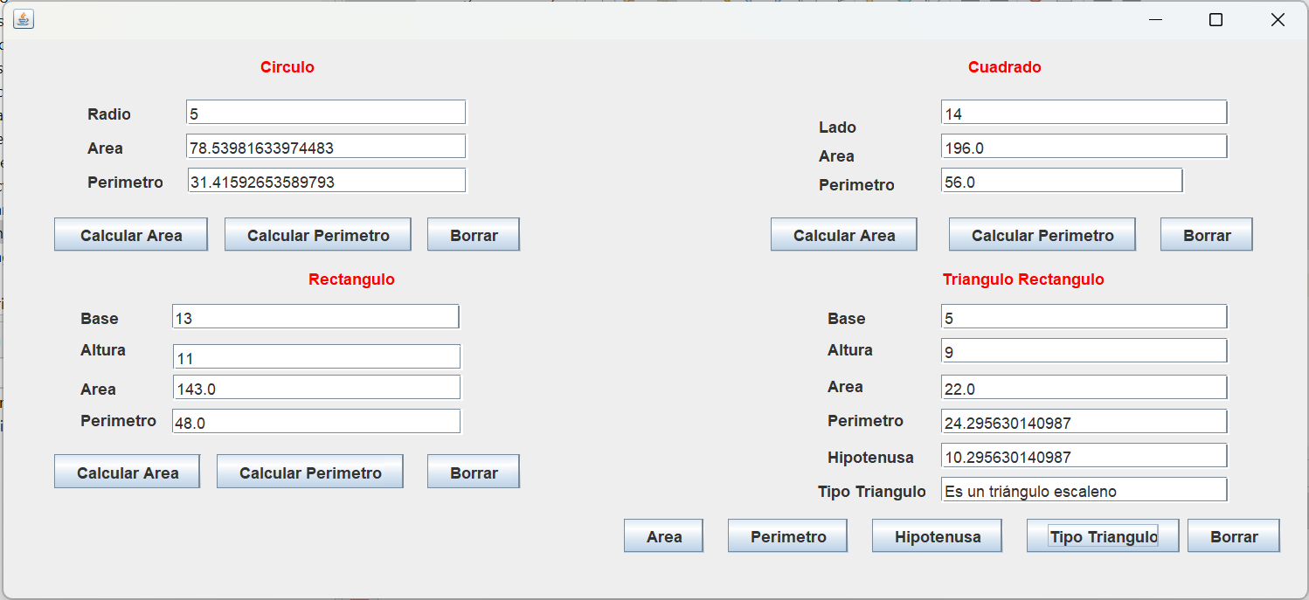

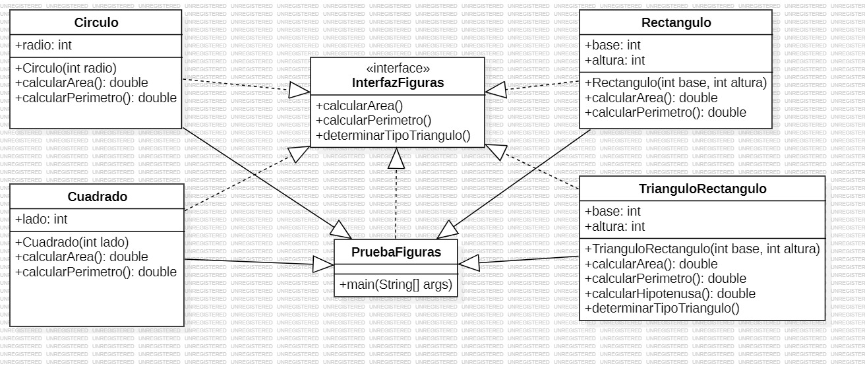**Diagrama UML**

**Links:** [**https://github.com/juancoficial7/actividad3/tree/main/PruebaFiguras**](https://github.com/juancoficial7/actividad3/tree/main/PruebaFiguras)